**PUSL3190 Computing Individual Project**

**Final Report**

‘MySizing’ Mobile Application for

Material related Size Recommendations

With React-Native and SpringBoot

Supervisor: Ms. Hirushi Dilpriya

Name: Gunathilaka M Chamodi

Plymouth Index Number: 10819486

Degree Program: BSc (Hons) Software Engineering

# **ACKNOWLEDGEMENT**

I would like to express my gratitude to my supervisor Ms.Hirushi Dilpriya for instructing and guiding me where I was lacking and supporting me to improve my project. Thus, would like to thank NSBM green university and Plymouth university for the new knowledge and continuous support throughout this project.

# **ABSTRACT**

The worldwide online shopping sales have been rapidly increased in comparison to the past few years, for all the sectors including apparel sector. Although apparel and clothing sales have shown a major growth in the online shopping, the return rates of these sectors also have been highly increased mostly among women. To overcome this issue, creating a system that recommends a best fitting clothing size for women would be great. Thus, through a mobile application, users can get size recommendations based on the preferred materials. For that, this app collects data from past customers about the previous purchases made from a specific clothing brand and then develops a mathematical model to give the best fitting output. Moreover, as for the front-end development it uses React-native and for the backend development uses java Spring Boot with MySQL database.

Table of Contents

**ACKNOWLEDGEMENT** 2

**ABSTRACT** 3

**List of Figures and Tables** 6

Chapter 1 7

**1.1 INTRODUCTION** 7

Chapter 2 9

**2.1 BACKGROUND RESEARCH** 9

**2.2 OBJECTIVES & DELIVERABLES** 10

Chapter 3 11

**3.1 LITERATURE REVIEW** 11

Chapter 4 12

**4.1 METHOD OF APPROACH** 12

**4.1.1 Data Collection method** 12

**4.1.2 Methodology** 15

**4.1.3 Programming Languages** 16

**4.1.4 Testing** 17

**4.1.5 Version Control** 18

**4.1.6 Code Structure** 19

**4.1.7 Third Party Libraries** 20

**4.1.8 Use case diagram** 21

**4.1.9 Class Diagram of Proposed System** 22

**4.1.10 ER Diagram** 23

**4.1.11 High-level Architectural Diagram** 24

Chapter 5 25

**5.1 REQUIREMENTS** 25

**5.1.1 Functional Requirements** 25

**5.1.2 Non-Functional Requirements** 26

**5.1.3 Hardware / Software Requirements** 27

Chapter 6 28

**6.1 END PROJECT REPORT** 28

**6.1.1 Evaluation and Conclusion** 28

**6.1.2 UI and UX features.** 31

**6.1.3 Business objectives** 34

Chapter 7 35

**7.1 PROJECT POST-MORTEM** 35

**7.1.1 Are project objectives fulfilled?** 35

**7.1.2 Are business objectives achieved?** 35

**7.1.3 Chosen technologies and development.** 35

**7.1.4 Things for future development.** 35

Chapter 8 37

**8.1 CONCLUSION** 37

**REFERENCE LIST** 38

**APPENDICES** 40

**Mobile Application UIs** 40

**Questionnaire survey** 47

**USER GUIDE** 51

**PID** 53

**STAGE PLANS** 70

**INTERIM REPORT** 71

**Records of supervisory meetings** 107

# **List of Figures and Tables**

Figure 1: Pie chart showing the importance of clothing materials. 7

Figure 2: The Questionnaire about the best fitting size recommendation system 12

Figure 3: Pie chart showing the importance of materials. 13

Figure 4: Pie chart showing respondents’ confidence about getting correct size. 13

Figure 5: Pie chart showing respondents’ preference about a size recommending application 14

Figure 6: Gantt Chart 15

Figure 7: Hosted MySQL database with its credentials. 16

Figure 8: Postman API request body showing the test HTTP requests. 17

Figure 9: MySQL database table of showing how the test post requests are being updated. 17

Figure 10: GET request example. 18

Figure 11: GitHub Repo branches. 18

Figure 12: Showing the number of commits. 18

Figure 13: React Native Code Structure 19

Figure 14: Config.js file. 19

Figure 15: Spring boot Code Structure 20

Figure 16: Use Case diagram. 21

Figure 17: Class Diagram 22

Figure 18: ER Diagram 23

Figure 19: High-level Diagram 24

Figure 20: Code set of user authentication 26

Figure 21: Code set of creating the mathematical model for Cotton clothing brand. 28

Figure 22: Code snippet of calculating whether logged-in user is in a grouped UK size 29

Figure 23: Showing use of Async Storage to temporary store logged in user’s username in login page. 29

Figure 24: Code snippet of getting the logged in user’s username and chest width in ‘SizeRec’ page 30

Figure 25: Code set of saving the feedback data to feedback table. 30

Figure 26: Code snippet of saving feedback data to polyester material table. 31

Figure 27: Frontend UI of the user feedback page. 31

Figure 28: code snippet of passing the product related data to size recommendation page. 32

Figure 29: UI of Size recommendation Page. 32

Figure 30: UI of PayPal gateway page 33

Figure 31: AWS free tier created instance. 35

Figure 32: The expired hosted MySQL database. 36

Figure 33: The instance is successfully connected and running. 36

Figure 34: The database connection issues. 36

Figure 35: Gantt Chart 70

**Main body of report**

# Chapter 1

## **1.1 INTRODUCTION**

According to a survey conducted by Coresight Research, within US apparel clothing brands and retailers, discovered that the average return rate of the online apparel sales in US is about 24.4% (Coresight & Zheng, 2023). The reasons for high return rates in online clothing are, user body measurements are not matching with the specific clothing brand’s size chart measurements and clothing item’s specifications such as material. Materials can be stretchable or non-stretchable and should be highly considered when buying the product. According to the questionnaire survey that conducted for this project, 62.5% of respondents stated that the material is important when purchasing a clothing item or an apparel as shown in figure 1 below. Thus, 31.3% of respondents stated that it is very important. None of the respondents say that the material consideration is not important.

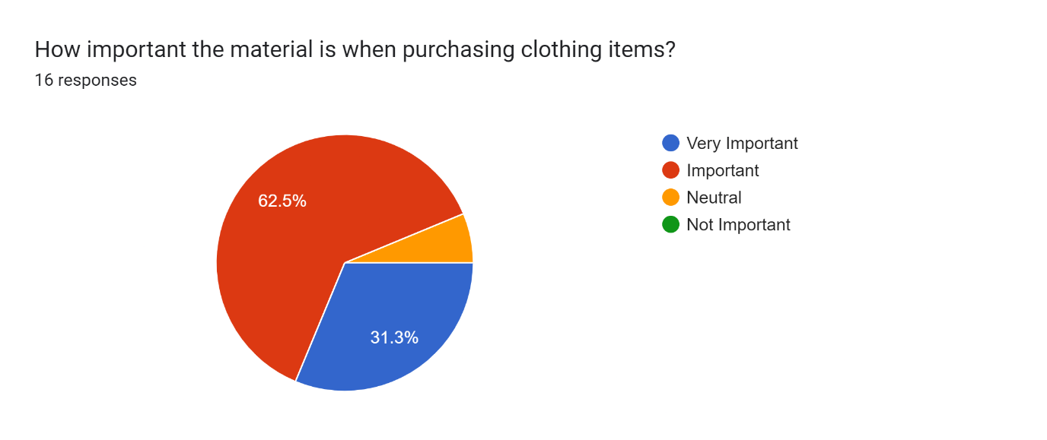

Figure 1: Pie chart showing the importance of clothing materials.

Cotton, Polyester, Linen, etc., materials can be considered as non-stretchable and usually require a bigger size of the product. While stretchable materials like Spandex blend fabrics such as Polyester/ Spandex blend or elastane need a smaller size in comparison to non-stretchable fabrics.

In a study that collected data from the in-person interviews were asked about online apparel shopping and its feedback. Both ‘product quality’ and ‘return and exchanges’ topics were mentioned 18 times each. Which mentioned more often than the other topics (Yin & Xu, 2021).

Since the quality of the product matters, the developed system provides the user with a feature to select the preferred materials of the clothing according to their likings. Which gives a certainty about the product quality. It can be fully 100% cotton/ polyester/ linen or else it can be a spandex blend material.

According to Statista, comparing to other retail product categories such as shoes, bags and accessories, the highest returned rate which is 26% is for the clothing items among all the categories (Dopson, 2023). Since not all the customers are happy with online clothing purchasing, developing a system that can recommend the best fitting size before buying the actual product would be a better solution.

This developed system can recommend a fitting size for the user according to the preferred material of the clothing item. Thus, system only focuses on a specific clothing brand and its previous purchases history from users. Since each clothing brand’s size chart measurements could be different from one another. So, it would be better to get each specific clothing brand’s purchase history data separately and develop a mathematical model to recommend the user fitting size according to the clothing brand. Thus, this system could be improved by adding more clothing brands and its purchase history.

The developed system is called ‘MySizing’ mobile application, which can recommend the perfectly fitting size for the user by getting one user specific body measurement such as user’s chest size. Then that measurement would be compared with the previous user’s purchase history to make that size recommendation. Although it only focuses about a specific clothing brand., using this exact solution can expand this system with collaborating with several other clothing brands. This system collects the data about customer’s order history through a page where user can enter their chest width, material of the clothing they bought, and the fitted size when do both physical and online shopping. Using all this data, the system can give the user a material-related size recommendation.

Data from several surveys found that men have more trust in online shopping (purchases) than women who reported have lesser trust (Kumar & Singh, 2014). Therefore, the developed system would be mainly focused on women and the age range of 20-54. Since women found difficulties with the materials related sizes mostly.

The developed system uses a mobile application which provides user-friendly user interfaces (UIs) for the user to get the recommended fitting size of the clothing item. In addition to that some more features are available in this application such as user feedback which could improve the accuracy of the system. Through the react native mobile application, the user can enter the user-specific body measurement which is the chest size, and that data would be sent to the related database tables to give the best fitting size. And technologies as react native for the mobile application frontend, MySQL database with java spring boot for the backend would be use as a full- stack.

# Chapter 2

## **2.1 BACKGROUND RESEARCH**

After the covid19 pandemic in 2019, the worldwide online shopping sales have rapidly increased. Furthermore, an 8 percent increment in online shopping sales can be seen within the next couple of years in comparison to the past few years, for all sectors including fashion clothing (Administration, 2021). Also, when talking about the brand and customer interaction, 72 percent of customers preferred to interact with the brand online (McKinsey_report, 2022).

According to a study, it reported that according to Bloomberg, even after the COVID 19 ended 41% of American people claimed to like online shopping (apparel and other items) more than visiting the shop and purchase items physically. Furthermore, it stated in a survey that conducted in 2022, online sales are booming in the China as ¾ of are related to clothing and fashion categories (Vaghasiya & Sitapara, 2023). These reported data display how much online shopping in apparel or clothing sectors has boosted up.

Although apparel and clothing sales have shown a major growth in online shopping, the return rates of those sectors also have been highly increased as stating 40% to 50% (Cullinane, et al., 2017). As the following research paper and other data shows, the high return rates globally have become a big issue in online appeal shopping. To overcome this problem, creating a system that recommends the best fitting clothing size for the customers would be great.

The daily average usage of mobile phones has increased in 2021 as research shows it is at least 4 hours a day (McKinsey_report, 2022). So, developing a mobile application where user enters the chest size and gather the user feedback of past purchases made from that specific brand to feed to the model to give excellent size recommendations would be the best solution.

## **2.2 OBJECTIVES & DELIVERABLES**

1. Size Recommendations

* Recommend the best fitting clothing size for each user according to the user chest width considering the material attributes.

1. Material selection

* Providing the user to select clothing items according to the preferred clothing material which can graduate the material quality of the item bought by the user.

1. More Accurate recommendations

* Making more accurate size recommendations with more user feedback data gathered about previous customer purchases.

1. Payment using PayPal Gateway and stock availability.

* Able to purchase and make the payment through PayPal gateway and user can get an idea about the current stock availability of an item.

1. Enhance online shopping.

* Improves online shopping experience with no return rates by providing an easy navigation system and user-friendly interfaces.

.

# Chapter 3

## **3.1 LITERATURE REVIEW**

A proposed system uses the user’s body image to recommend a fitting size for the user. This approach is done by getting the user body measurements through the provided body image with 3d body shape. Thus, to test the application it has conducted surveys and group interviews that are semi-constructed (Peng & Al-Sayegh, 2014).

From the ‘FashionFit’ system, user can virtually try on any unclothing branded clothing item from any retailers using AI. The 3D pose maps the user’s body and Neural body fit model creates 3D models of the body according to the body shapes. Then able to virtually try on the clothing using GANs framework in machine learning (Hashmi, et al., 2020). In that system it uses 3D body pose to map the user’s body based on an image.

A system where gathers the data about user’s previous purchases, and with the specific clothing item’s details, predicts the suitable size of for user using the GBM classifier as reduces the return rates (Abdulla, et al., 2019). By analyzing a collection of data, the system would be able to tell the size of clothing that is recommended for the user and without fully need of the visualization.

According to a developed a system called ‘Avatar manager system’, the user can try on the selected clothing item he/she likes on an avatar when do online shopping. Men and women can select a suitable body type which matched for each user from the given options. Then after should select the preferred body size such as small or large or extra-large, etc. In the end of this process user can adjust the avatar’s body measurements compared to the user’s body measurements. Then it would display how the selected clothing item would fit on according to the user’s body measurements (Polke & Kumari, 2018).

THE FIT (Korea) implemented an AI-based system in online shopping malls, that recommends the suitable shoe size for the customer. This application collects the data about customer’s order history and compares that data with the customer’s actual foot size and recommends a shoe size from currently available shoe products (Yuan, et al., 2021).

According to the system that implemented using a Hierarchical Bayesian model, it can recommend a size for the product by checking the highest probability about customer keeping the product without returning it and according to their preference through using a survey conducted about millions of purchase data (Romain Guigourès, 2018).

# Chapter 4

## **4.1 METHOD OF APPROACH**

### **4.1.1 Data Collection method**

Data gathering techniques can be listed in 2 parts, such as primary and secondary data gathering techniques. As for the primary data gathering, have conducted a survey questionnaire to gather data about the different perfectives of the users for this developed system.

Figure 2: The Questionnaire about the best fitting size recommendation system

The figure 2 shows about the created survey details such as asking the participants about his/her gender, age, and how important the material is when buying an clothing item, the confidence about getting the expected matching size when buying the item online, and if the participants has ever used/experienced an online size recommendation system or an app, moreover, if the participants like to have/ use an online size recommending system application in their day to day life. Thus, the full questionnaire can be viewed under the appendix section.

Through this conducted survey it has identified the developed application’s target audience as females between age 20 to around 54. While all the respondents were female and with all combined 93.9% of respondents are in between the age of 20-54. (Considering that under 20 aged females would not be used for collecting the data since the developing application mainly targets ages between 20-54 women).

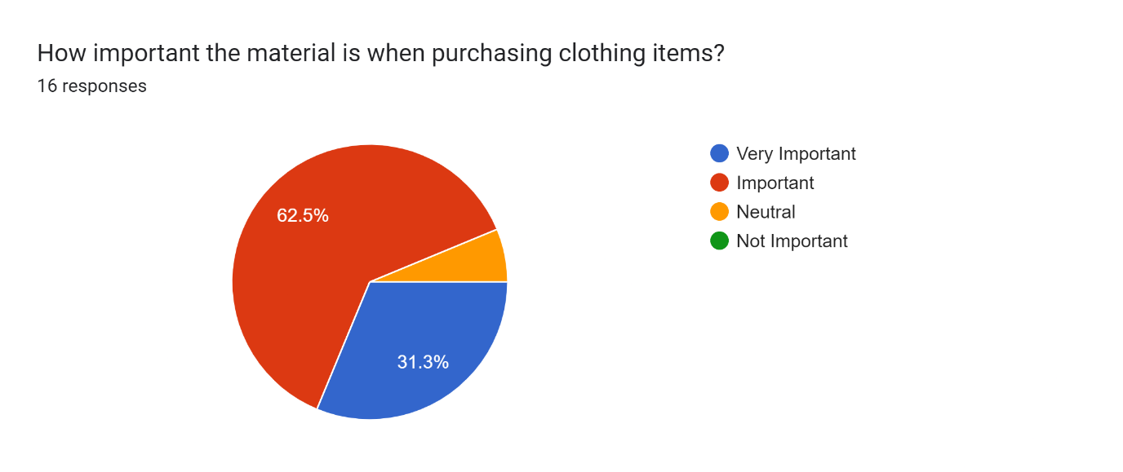

Figure 3: Pie chart showing the importance of materials.

Forms response chart. Question title: How confident are you in choosing the correct size when do online shopping?
. Number of responses: 16 responses.

Figure 4: Pie chart showing respondents’ confidence about getting correct size.

According to the following pie chart results in figure 3 and 4, it results that how important the material and how confident the users are about buying the correct size when purchasing cloths online. Majority of participants about 62.5% think the material is very important while 50% of participants think getting his/her size correct is very important.

Thus, according to the survey 56.3% of the participants stated that he/she has not yet experienced or ever used an online size recommendation system although another considerable 43.8% amount of people has experienced it. So, from the people that have not used similar systems, 93.8% like to use an online size recommendation system as shown in figure 5 below. This is done while considering the material aspects of the item and compare the user’s body measurements.

Forms response chart. Question title: Would you like an app that provides size recommendations for you based on your body measurement relates to clothing item&apos;s material ?
. Number of responses: 16 responses.

Figure 5: Pie chart showing respondents’ preference about a size recommending application

### **4.1.2 Methodology**

Figure 6: Gantt Chart

This developed system used a hybrid approach methodology, where it is a combination of waterfall and agile methodologies. As the Gantt chart shows above in figure 6, in week nine the project was on hold, then started back in 10th week where the frontend design was first started and continued straightly till week 14. This can be considered as waterfall approach where UI changes not applied later in the project. In the 15th week, have started agile approach and separated the work into iterations. Thus, in an iteration the frontend and the backend of a feature is developed while do testing for that specific feature. Likewise, the iterations approach in agile have executed until the week 22. Then after final testing for the whole application is done. Finalizing the project is done in week 24 (end of the April).

### **4.1.3 Programming Languages**

React-native framework is used to develop the frontend of this mobile application, while for the backend it uses Java Spring Boot framework with MySQL database. This can be considered as a great stack for developed a mobile app. MySQL remote database is hosted through ‘freesqldatabse.com’ with the free database that it provides with a hosted server as shown in the figure below. Though it was considered as a free database, the free hosting service was only applied for one week (7days). So, after that time period user should use the MySQL local server credentials and download the database into their local machines and run the backend server manually through downloading the spring boot application.

Figure 7: Hosted MySQL database with its credentials.

Anyhow, the java spring boot backend server is hosted with AWS (Amazon Web Services) with free tier. Thus, as a jar file, this system’s created spring boot project folder file would be uploaded to the server of that related instance with EC2 service. Moreover, it uses an elastic IP address (13.48.121.164) which is a static IPv4 address.

### **4.1.4 Testing**

Uses Postman application as a tool to test the HTTP requests and its responds. Inside the collection named ‘Sizerecom’, all the requests would be mentioned. As an example, a new POST request is created and would be sent to the related endpoint and that request would be sent in a JSON format as shows in the figure 8 below,

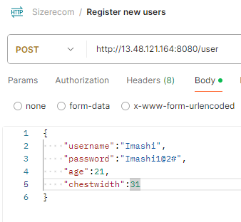

Figure 8: Postman API request body showing the test HTTP requests.

When the request is sent, it will update the MySQL database tables as in the figure 9 below. So, then it could test the endpoints in this system as it uses POST, GET, PUT requests. Thus, the ID is auto incrementing by one using the ‘@GeneratedValue’ annotation with ‘@Id’ annotation. The Id is then used as the primary key.

Figure 9: MySQL database table of showing how the test post requests are being updated.

GET requests are made to get (retrieve) the data. And as for the GET method testing, the below figure shows how the best fitting size is recommended according to the chest width. For the ‘/polyester/recommend/{cw}’ end path, the system would get the user’s logged in chest width using the Async Storage. Then this data would be sent to the relevant size recommending page and after the calculations it would recommend the best fitting UK size for that user selected material.

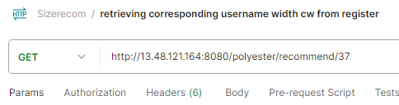

Figure 10: GET request example.

### **4.1.5 Version Control**

Since it is important to use a good amount of version control to this project, to keep backups and for code maintainability it used Git as a version control tool. Thus, in this developed application, the data is committed or saved in two branches as ‘testdev’ and ‘main’ branches as in the figure 11 below. When editing and testing a specific feature related code set it uses the testdev branch. Then, if that feature is done testing and works well it would be merged with the main branch.

Figure 11: GitHub Repo branches.

Figure 12: Showing the number of commits.

### **4.1.6 Code Structure**

Figure 13: React Native Code Structure

In the react-native frontend folder, a folder called ‘all’ is created as shown in figure 13 where it has sub folders named after each feature of this developed application. The ‘config.js’ is the file that contains the endpoint path such as ‘http://<IP>:8080’. This path is allocated to a variable and that variable would be imported in every component to avoid code duplication and improve flexibility as shown below in figure 14.

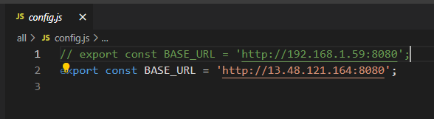

Figure 14: Config.js file.

When talking about the java spring boot backend, the advantage of using this technology is having a clear code structure where it is easy to maintain. Spring boots specialty is to create microservices. In this developed application it has allocated a feature into an iteration. Thus, as in the provided figure 15 below the controller, model, repository folders have separately created and inside the model folder it has all the codes related to create the database model for the MySQL database. In the controller folder it has mentioned the ends points with the related codes to perform the tasks of each feature. Furthermore, if have to find any fields using its field name, have to mention it in a repository interface connected to its model.

Figure 15: Spring boot Code Structure

### **4.1.7 Third Party Libraries**

For the mobile application have used third party components and libraries to add more additional functionalities to the system while creating the application well organized by enhancing the user experience also.

1. @react-navigation/native

* This can navigate the user from one screen to another screen using the navigate (‘’) method.

1. @react-navigation/stack

* This creates a stack, so if put ‘A’ screen on top and ‘B’ screen under that, this library can stack them and would go to the screen ‘A’ first the navigates to the screen ‘B’.

1. npx react-native link react-native-gesture-handler react-native-screens react-native-svg

* Since the ‘Button’ component in react-native does not include many options when it comes to editing or styling the component, in here it uses a component called ‘TouchableOpacity’ which can easily be styled and act as a button.

1. react-native-screens library.

* uses to create a stack where navigate between the screens.

1. @react-navigation/native @react-navigation/bottom-tabs

* to create the bottom navigation bar in most of the pages

1. @react-native-picker/picker

* To create the dropdown list in the ‘Material.jsx’ page

1. Axios library

* uses this library to make http requests from the react-native app to the server.

1. @react-native-async-storage/async-storage

* uses to save the logged-in user’s username with its chest width.

### **4.1.8 Use case diagram**

Figure 16: Use Case diagram.

This developed application’s actors are external objects that can be listed as primary actors, secondary actors. The primary actor in the developed system is the user or the customer which displays on the left side of the container system as in figure 16 shows above. These people can use the system to get the size recommendations.

In the other hand the secondary actor in here is the clothing brand shown in the right side of the figure 13. It reacts when the user or the customer selects an item and checks the stock availability and also when making the payment.

As for the use cases it has ‘base’ and ‘included’ use cases. For example, the login ‘base use case’ needs ‘included use case’ to verify and authenticate the user. Furthermore, this system has ‘extended use case’ which the relationship with the ‘base use case’ does not happen every time, such as when login to the system the login error message would not occur every time.

### **4.1.9 Class Diagram of Proposed System**

The visibility of the methods and attributes are shown using the + or – symbol public and private access specifiers accordingly as shown in the figure 17 below. Users can give feedback as well as enter the chest size. After entering the user size, the user could select a clothing item from the list, then from that would give user the best fitting size recommendation and the stock availability.

Figure 17: Class Diagram

### **4.1.A diagram of a diagram Description automatically generated10 ER Diagram**

Figure 18: ER Diagram

The entities of this system are the user, feedback, and clothing items. As shown in figure 18, user can send feedback, also assume that one user sends only one feedback while feedback is sent by a user. Furthermore, the clothing items have user feedback, and the user can also buy the selected clothing item.

### **4.1.11 High-level Architectural Diagram**

As for this high-level diagram many changes appeared for this developed system when compared to previous designs. According to this high-level diagram in figure 19 below, from react-native application (frontend), first would send the http request to the server. Then after processing the requests and it performs the specific tasks while connecting and interacting with MySQL database as necessary.

Figure 19: High-level Diagram

# Chapter 5

## **5.1 REQUIREMENTS**

### **5.1.1 Functional Requirements**

* Provide the chest width to get the best fitting size.
* Using only one body measurement which is the user chest size (width), is more convenient for the user. The user only has to measure only one body measurement rather than taking a lot of time to give all other body measurements.
* Gathering feedback data
* User can leave feedback about their previous purchases made from this specific brand, so that it would improve the accuracy of the size recommendations with the time.
* Selecting clothing material.
* A feature for the user to first select a material such as cotton, polyester, or spandex blend fabrics (such as blend of polyester, elastane). After selecting the preferred material could select a clothing item from the list of clothes according to the user-selected material.
* This value-added feature helps the users to find the exact same material that they are searching for. When the selected clothing item is delivered, can find whether it has the exact same material attributes. This minimizes low quality and wrong order delivery. Thus, increases brand loyalty.
* Mathematical model.
* The mathematical model would compare both the user-specific body measurement (chest size) and the clothing material to find the best fitting clothing size such as UK size 8/ 10/ 12/ 14/ 16.
* User authentication.
* After registering, user can login to the system by providing their credentials and the logged user’s password and username would be checked with the existing user details.
* Feature to see the stock availability.
* Make payment using PayPal Gateway.
* Payment using PayPal sandbox using smart buttons feature, the user can make the payment after getting the size recommendation.

### **5.1.2 Non-Functional Requirements**

* Security:

According to figure 20 below, only if the user exists in the system the user able to login. Inside a table called ‘Register’ all the registered user details would be saved. Then after the user logs in, data would be retrieved and would be compared with the existing user details.

Figure 20: Code set of user authentication

* Accessibility

The application can run on Android smart phones. Though it has only been tested on android, this mobile application should be able to run on IOS as well since react-native is a cross-platform.

* Maintainability

Have used getters and setters in java encapsulation as a security measurement. Which helps to improve maintainability of the code structure and the security. Thus, since there is a separated folder for model, repository, controller related codes in java backend, it is easier for the developers to find an error and make the necessary changes accordingly.

* UI and UX

Provides better user experience and user-friendly UI while securing the data. As users can choose the clothing items from different clothing materials, it is very convenient for the user in both UI and UX aspects.

### **5.1.3 Hardware / Software Requirements**

* Hardware

A Mobile phone (Android preferred) and a computer that has accessed to Wi-Fi and has enough RAM (ex: 8GB and 8GB< would be preferred) and CPU.

* Software

Node js should be installed prior to installing this application. Thus, Visual studio code IDE is used to run the react-native application. IntelliJ IDEA to run the backend server using java spring boot. As for the database, MySQL workbench application is used.

# Chapter 6

## **6.1 END PROJECT REPORT**

### **6.1.1 Evaluation and Conclusion**

* Accurate size recommendations

The mathematical model that is used to give the size recommendations can be improved with the amount of data that is fed to the model. It can then be improved in accuracy and as well as in reliability. Even if a person put wrong data, the model would not give false output. The reason for that is because in the model, after grouping the chest widths by its UK sizes, the range of the chest widths related to that UK size is only calculated through using the most frequently appeared or occurred chest widths only. This could help with giving false and less accurate size recommendations. Since it is focusing on one clothing brand, the recommendation using that specific brand’s feedback data should be mostly accurate.

The creation of this model is as follows in figure 21 and 22,

Figure 21: Code set of creating the mathematical model for Cotton clothing brand.

The user feedback data that is saved to the related material tables such as ‘fbSpandex’ table, ‘fbCotton’ table, ‘fbPolyester’ table in the MySQL database, would be grouped by the UK sizes, such as for UK 6 what are the chest width sizes that has entered by other users as feedback as figure 21 shown above. For this it is using HashMap in java to give a key value to each UK size group. Then after, from grouped UK size it would find the most frequently appeared chest widths. From that chest widths it would calculate what are the minimum and maximum chest width range for that grouped UK size as in figure 22 shows below. Then, it would create a range where it has the specific UK size with its chest width size range.

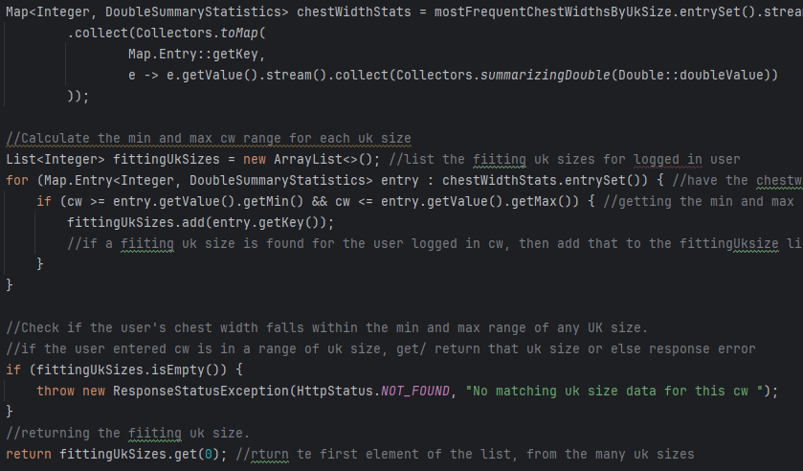

Figure 22: Code snippet of calculating whether logged-in user is in a grouped UK size

Furthermore, after this analysis and calculation when the system retrieves the logged in user’s chest width, it is able to find the best fitting UK size for that logged in person. To find the logged in user’s username have used Async Storage as shown in figure 23. This username would be passed to the size recommendation page to find the matching chest width size for that using the set method.

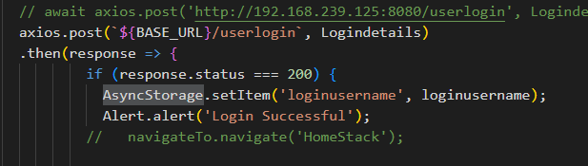

Figure 23: Showing use of Async Storage to temporary store logged in user’s username in login page.

Figure 24: Code snippet of getting the logged in user’s username and chest width in ‘SizeRec’ page

* Material selection

The developed system recommends sizes based on the material aspects of the clothing. Also, this system can provide more varieties of materials with the development. All the feedback data would be first saved to the ‘Feedback’ table as follows in figure 25. Using the save () method the created feedback object data would be saved.

Figure 25: Code set of saving the feedback data to feedback table.

After saving the data, if the material of the clothing item is polyester, then get the entered feedback table’s chest width and UK size and would set those to the polyester table columns as below in figure 26. Thus, the same approach would be executed for other materials as well.

Figure 26: Code snippet of saving feedback data to polyester material table.

### **6.1.2 UI and UX features.**

As this system uses a mathematical model to give size recommendations, this application provides the user a user feedback page where it gathers data about the material, the chest width and the fitted UK size of the clothing item she bought as in the figure 27 UI shows. Thus, using these feedback data can analyze how the sizes are being vary with the material of the clothing.

Figure 27: Frontend UI of the user feedback page.

The UI of the size recommendation page displays the logged in user’s chest width and the price of that selected item with the stock count. Those data would get retrieved from the material related database tables. As an example if take the cotton material as in figure 28 related code, when click on an image from the cotton image list using the created ‘handleImage’ press function the image product related data (item id, price, stock) would be retrieved and passed to the ‘SizeRec’ page as in figure 29 below using the useNavigation( ) function in react native libraries.

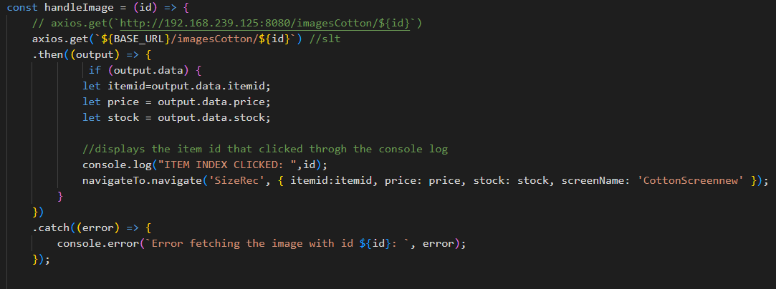

Figure 28: code snippet of passing the product related data to size recommendation page.

Figure 29: UI of Size recommendation Page.

Furthermore, for the user’s convenience, users can make payment using the PayPal smart buttons as it uses JavaScript SDK. For this integration had to first create a PayPal developer account and then using that, a new PayPal business account was created to test this PayPal gateway using the provided credentials such as the email address and password.

Figure 30: UI of PayPal gateway page

.

### **6.1.3 Business objectives**

* Ables to boost the sales revenue of clothing brands.
* According to an analysis, found that once people are satisfied with the (online) shopping experience, the customer would be loyal to the brand in a behavioral way or an attitudinal way (Al-dweeri, et al., 2017). Therefore, it enhances customer satisfaction and can boost the brand’s revenue by increasing the sales.
* Reducing the return rates of the apparel industry.
* Enhances user engagement.
* Using customer feedback, it improves the reliability of the model and the user engagement in this system.
* Able to improve the in-person shopping /physical shopping experience.
* Shopping malls which have different clothing brands, this system can be introduced as a new feature development to their already existing mobile or web application(s), which enhances the user experience.
* Secured data.
* Data is authenticated while ensuring the privacy of the data.

# Chapter 7

## **7.1 PROJECT POST-MORTEM**

### **7.1.1 Are project objectives fulfilled?**

As for the self-evaluation, this developed system could be more improved from training the model with top design types such as A-Line, Off-Shoulder, Button-Up, etc., along with the material related data from users purchase history. However, the currently developed system can also provide accurate reliable size recommendations as for now with more and more user feedback data while successfully fulfilling overall project goals and objectives.

### **7.1.2 Are business objectives achieved?**

Since this project could reduce the returns rates in online shopping it enhances the customer satisfaction of the clothing brand, which could also enhance the customer engagement with the brand. Thus, this developed system can be introduced to different clothing brands so they can add this system as a new feature to their existing systems in mobile applications.

### **7.1.3 Chosen technologies and development.**

Moreover, this developed system was planned to be developed using the Android studio, but using Android studio with java spring boot together with MySQL database is somewhat difficult. So, React-native was used as the frontend development of the mobile application. Thus, it would also have been better to use a cloud database for this project where it would not be needed to host. Overall, the use of react native for frontend with java spring boot and MySQL database for the backend is a great full-stack technology.

### **7.1.4 Things for future development.**

When talking about limitations and future developments, this application’s backend server is hosted with the AWS free tier (figure 31) and MySQL database with ‘freesqldatabase’ as mentioned in above chapters. However, the free hosted MySQL database was unexpectedly expired (figure 32) in a short period of time (within one week), the hosted backend database with AWS also could not be used since in java spring boot backend application it has to provide the database credentials in the ‘application.properties’ file. Therefore, as for the future development it is better to be able to host both the backend server and the database together.

Figure 31: AWS free tier created instance.

Figure 32: The expired hosted MySQL database.

In figure 33 shows how the created instance with AWS free tier is connected to the instance with the elastic IP address.

Figure 33: The instance is successfully connected and running.

In figure 34 it is showing that the backend server is running from uploaded jar file which contained the backend spring boot application. But indicates that some issues with the MySQL database connection which related to the hosted database being expired.

Figure 34: The database connection issues.

# Chapter 8

## **8.1 CONCLUSION**

Finding the best fitting size for a woman can be a bit tricky and difficult in online shopping. This developed system would give the size recommendations for a specific clothing brand considering the material attributes. Thus, in this project it has mentioned only one specific clothing brand called ‘clothing brandA’, but for further development can collaborate with other different clothing brands. From that can gather data about previous customer purchases made by each brand to train the model which can improve the model’s scalability. Thus, accuracy can be improved with the amount of data that is used to train the mathematical model.

For this system, to develop the mathematical model it was planned to use the questionnaire result data. However, since the responses from the questionnaire were not enough, the accuracy of training the model using those data would not be reliable. So, this developed system got dummy data from the user feedback page about user’s previous purchases data such as material, fitted UK size and material details. Though it has used dummy data here, in real-life scenario, this application can be trained using the real customers. To make this application more user-friendly and for the user’s convenience, can use image processing techniques to get the user’s body measurements using the user’s body image. Not only the chest width but can use other measurements such as, waist size, sleeve size also.

# **REFERENCE LIST**

1. Coresight & Zheng, S., 2023. The True Cost of Apparel Returns: Alarming Return Rates Require Loss-Minimization Solutions. [Online]   
   Available at: https://coresight.com/research/the-true-cost-of-apparel-returns-alarming-return-rates-require-loss-minimization-solutions/  
   [Accessed 13 November 2023].
2. Yin, W. & Xu, B., 2021. Effect of online shopping experience on customer loyalty in apparel business-to-consumer ecommerce, s.l.: Sage Journals.
3. Dopson, E., 2023. Ecommerce Returns: Expert Guide to Best Practices (2024). [Online]   
   Available at: https://www.shopify.com/enterprise/ecommerce-returns  
   [Accessed 12 November 2023].
4. Kumar, D. V. & Singh, R., 2014. Women Online Shopping: A Critical Review of Literature, s.l.: SSRN.
5. Administration, I. T., 2021. *eCommerce Sales & Size Forecast.* [Online]   
   Available at: https://www.trade.gov/ecommerce-sales-size-forecast  
   [Accessed 10 November 2023].
6. McKinsey_report, 2022. *State of Fashion Technology Report 2022.* [Online]   
   Available at: https://www.mckinsey.com/industries/retail/our-insights/state-of-fashion-technology-report-2022  
   [Accessed 20 May 2024].
7. Vaghasiya, C. & Sitapara, J., 2023. *A STUDY ON RETURNS RATES IN THE FASHION INDUSTRY WITH REFERENCE TO AN E-COMMERCE BUSINESS,* s.l.: JETIR.
8. Cullinane, S., Karlsson, E., browne, m. & Wang, Y., 2017. *Retail clothing returns: A review of key issues,* s.l.: ResearchGate.
9. Peng, D. F. & Al-Sayegh, M., 2014. *Personalised Size Recommendation for Online Fashion,* s.l.: ualresearchonline.
10. Hashmi, M. F. et al., 2020. FashionFit: Analysis of Mapping 3D Pose and Neural Body Fit for Custom Virtual Try-On, s.l.: IEEE.
11. Abdulla, G. M., Singh, S. & Borar, S., 2019. Shop your Right Size: A System for Recommending Sizes for Fashion products, s.l.: ACM Digital Library.
12. Polke, N. & Kumari, S., 2018. Avatar Manager System for Online Fashion Clothing APP, India: IEEE.
13. Yuan, Y., Park, M.-J. & Huh, J.-H., 2021. A Proposal for Clothing Size Recommendation System Using Chinese Online Shopping Malls: The New Era of Data, s.l.: MDPI.
14. Romain Guigourès, Y. K. H. K.-S. S. B. S., 2018. A hierarchical Bayesian model for size recommendation in fashion. s.l., ResearchGate.
15. Al-dweeri, R. M. et al., 2017. The Impact of E-Service Quality and E-Loyalty on Online Shopping: Moderating Effect of E-Satisfaction and E-Trust, s.l.: ResearchGate

# **APPENDICES**

## **Mobile Application UIs**

The mobile application User Interfaces are as follows. First the loading page and the sign-up page.

The login page and user authentication.

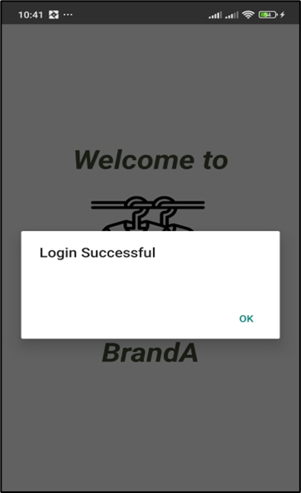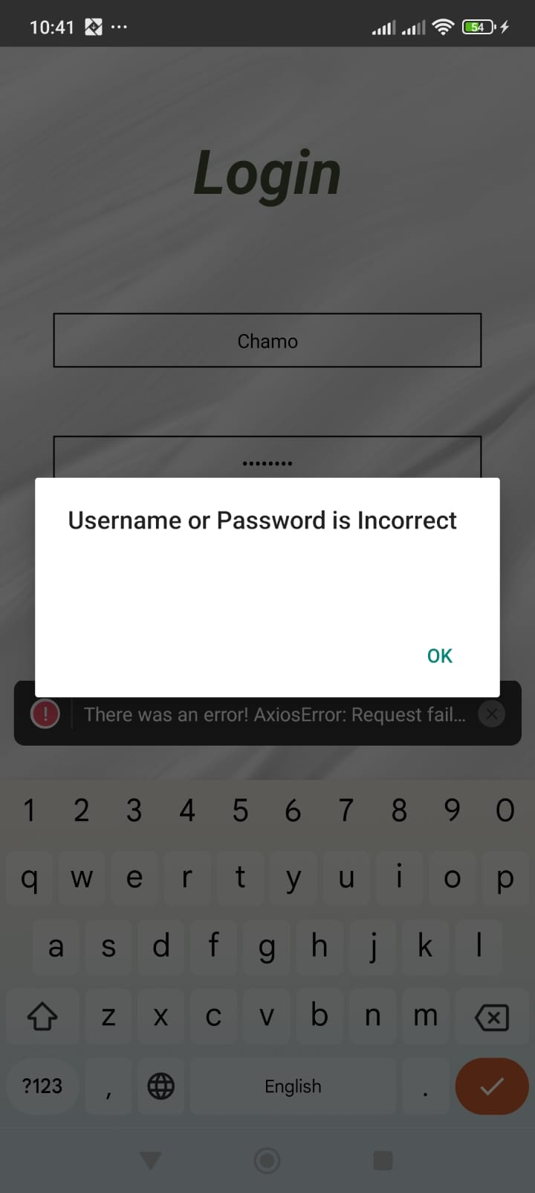

Material selection page and polyester material clothing list.

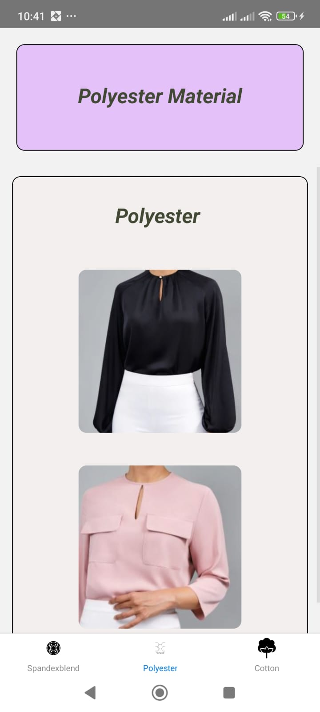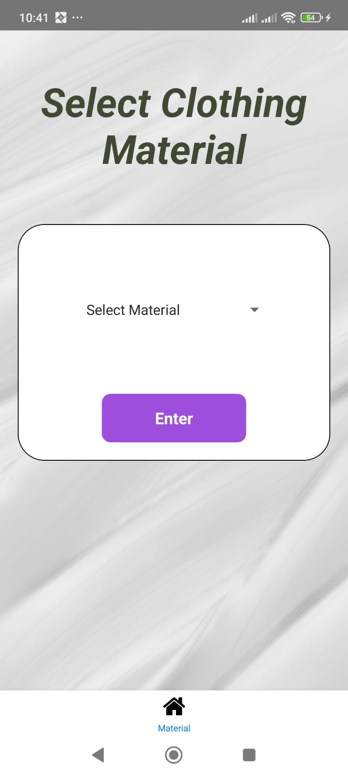

Cotton and spandex blend material clothing list.

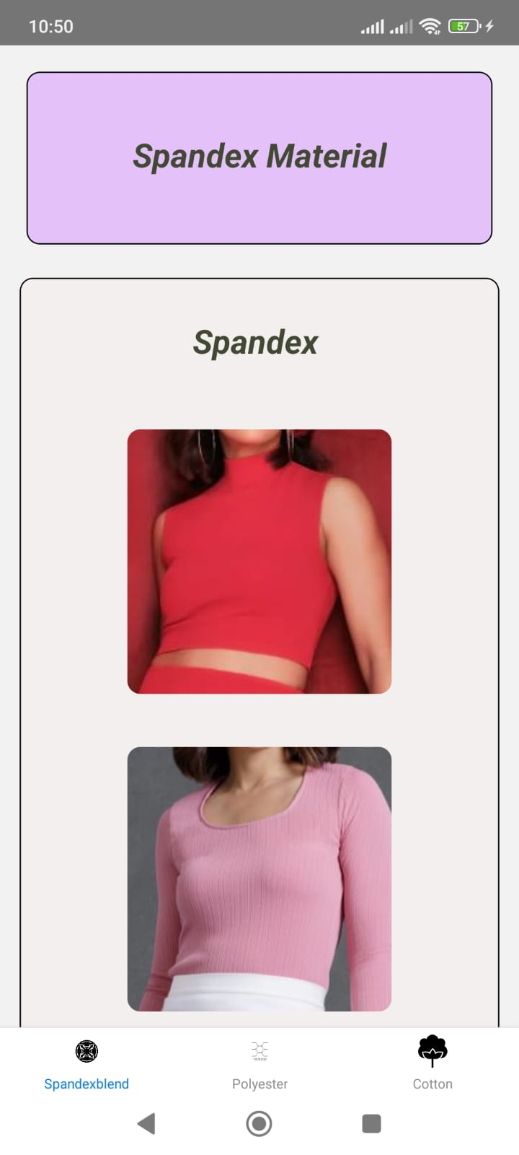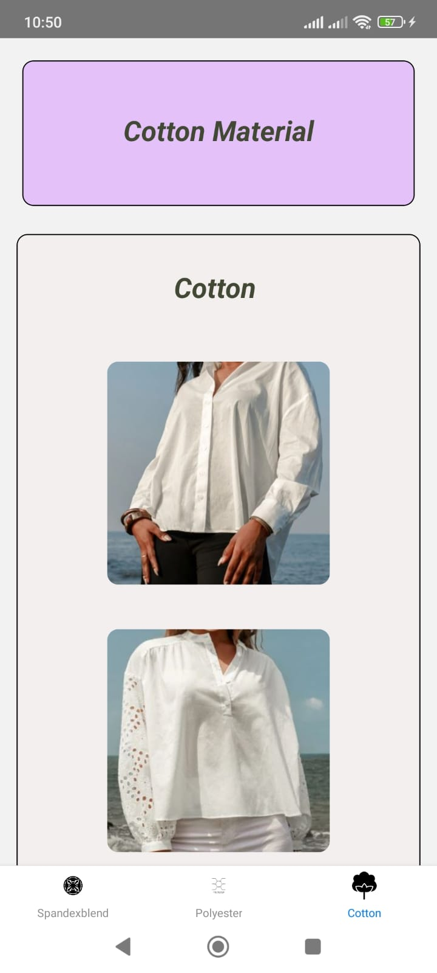

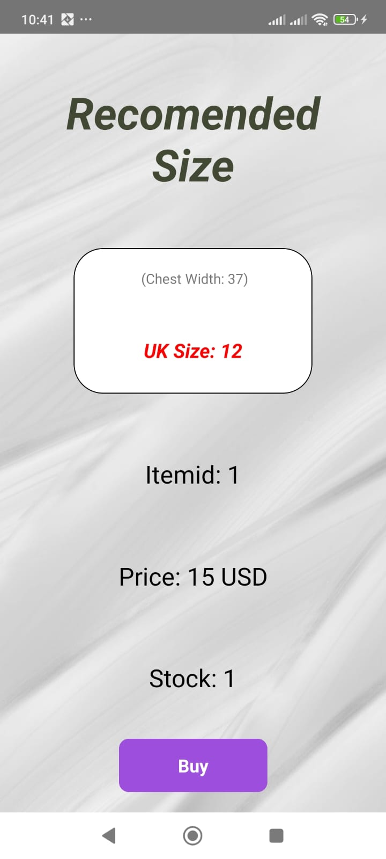Size recommendation page and buy page.

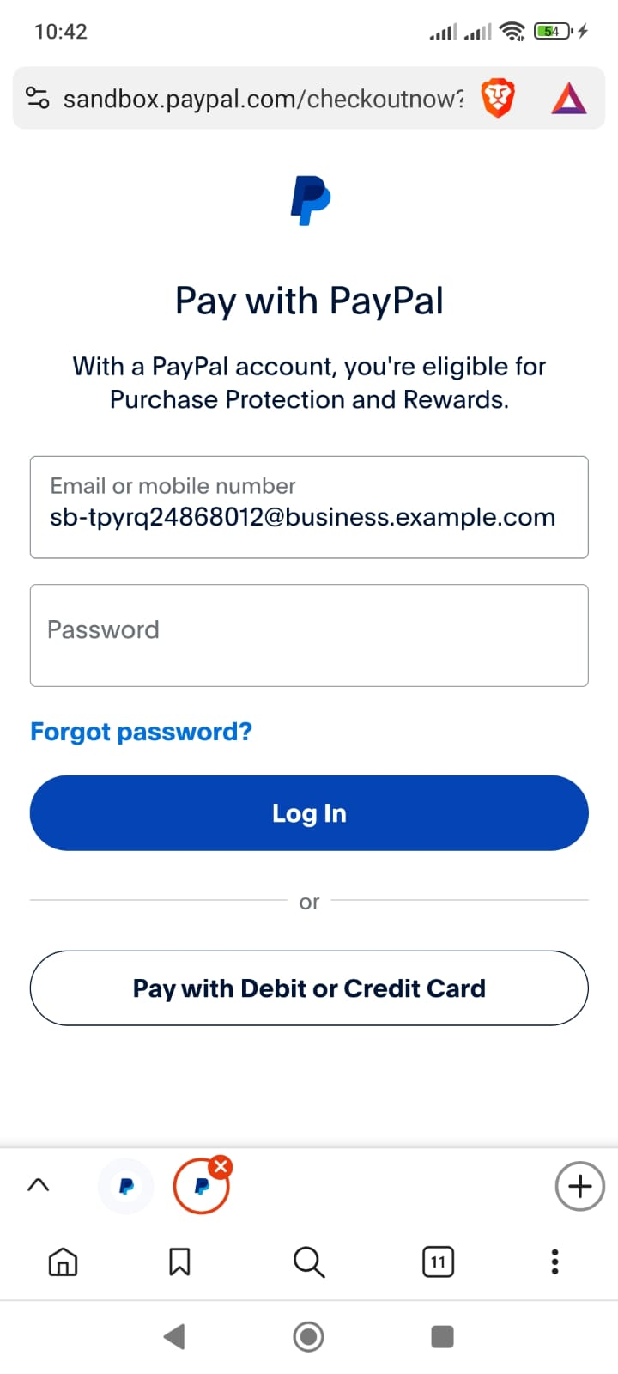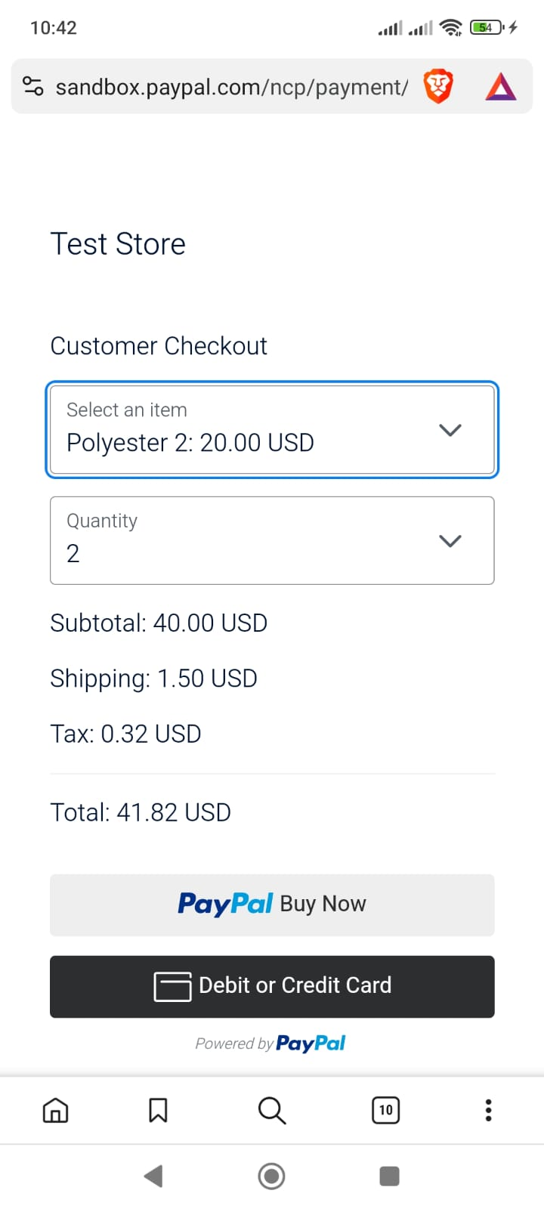PayPal Gateway with its login user account.

The user feedback page.

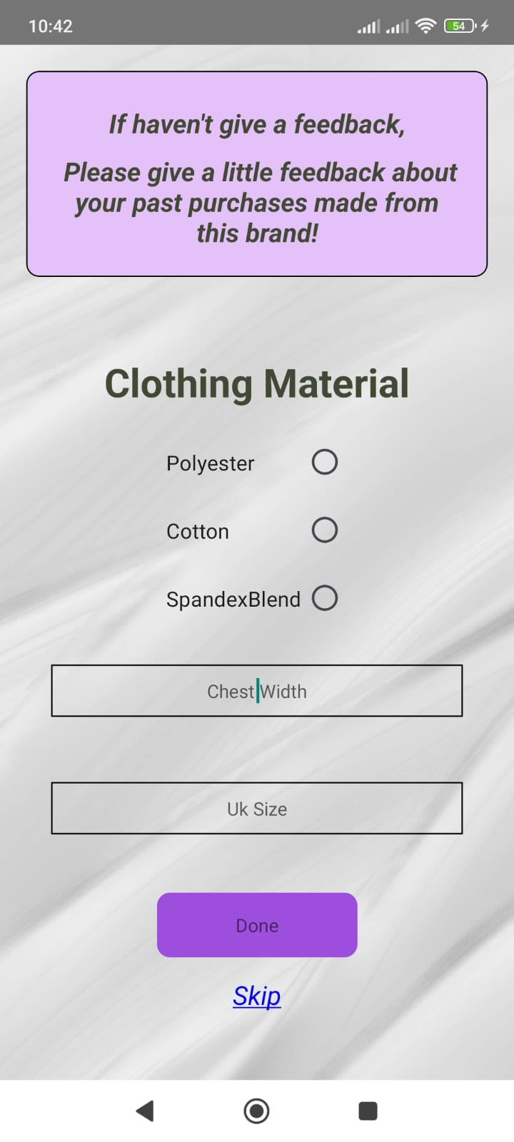

## **Questionnaire survey**

The questionnaire about the developed system can be seen below respectively. First asking participant about the gender and the age.

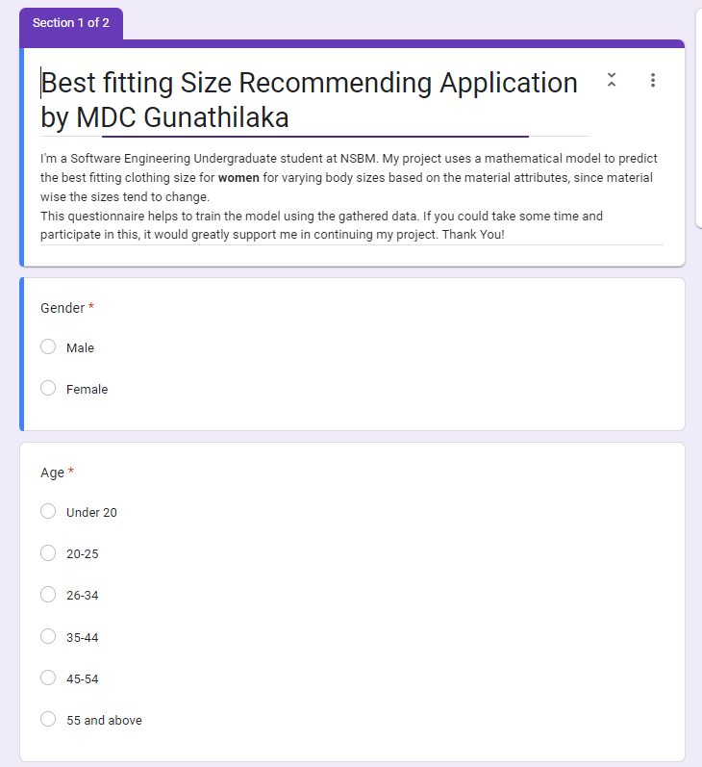

Next, about the importance of the material and confidence in online shopping question.

If user has ever experienced online shopping and preference about online size recommending app.

Asking about the women sizes in different materials.

Asking about the spandex blend materials preferred UK size and any other additional feedback.

# **USER GUIDE**

* Download the '10819486_SourceCode’ zip folder to your machine. Unzip it.

The backend server is hosted using AWS EC2 instances. But due to hosted MySQL database service being expired do as follows,

* **Backend Setup: Spring Boot with MySQL**

1. Start the MySQL server using XAMPP (or any preferred s/w).
2. Navigate to the 'springbootbackend' folder and configure the application.properties file with your MySQL local server credentials.
3. Import the 'newsqldb' SQL file to your MySQL database using MySQL workbench or through localhost phpMyAdmin.
4. Run the backend application using your java IDE (IntelliJ is preferred)

* **Frontend Setup: React Native**

On Android Studio,

Install the Android SDK- Android 14 (UpsideDownCake)

Download Android SDK Platform 34 with, Intel x86 Atom_64 System Image or Google APIs Intel x86 Atom System Image.

(For furthermore details visit,

<https://reactnative.dev/docs/0.73/environment-setup>

1. Connect your machine with mobile phone(android) using a USB cable.
2. Do the follow changes in your mobile settings,
   1. Turn on the developer setting.
   2. Allow installation via USB.
   3. Revoke USB debugging authorizations.
   4. Turn on USB debugging.
3. Check the authorized devices by using 'adb devices' command in command prompt.

(Your phone and machine should be in the same network)

1. Run the 'ipconfig /all' command and copy the IPv4 that under ‘Wireless LAN adapter

Wi-Fi’.

1. Navigate to the 'newreactmobile' folder and open the application using your preferred IDE (ex: visual studio code)
2. Install dependencies inside the folder using 'npm install' command.
3. Put and change the IP address in the /all/config.js file using the copied IPv4.
4. Start the React Native Metro server with 'npx react-native run-android' command inside the same folder for android devices.
5. After the mobile application launches to your mobile device, do the following steps.
6. Register as a new user or,
7. Login using the following credentials,

username: User1

password: User1@2#

or,

username: Chamo

password: Chamo1@2#

1. For PayPal login credentials use,

Email: sb-tpyrq24868012@business.example.com

Password: HM4(g+g8

# **PID**

**Project Initiation Document (PID)**

**Table of Contents**

Chapter 01 55

**Introduction** 55

Chapter 02 57

**Business Case** 57

2.1 Business Need 57

2.2 Business Objectives 57

Chapter 03 58

**Project Objectives** 58

Main objectives 58

Specific objectives 58

Chapter 04 59

**Literature Review** 59

Chapter 05 61

**Method of Approach** 61

Mathematical Model 61

Database and Integration 63

High level architecture 63

Chapter 06 64

**Initial Project Plan** 64

Chapter 07 65

**Risk Analysis** 65

Technical risks 65

Operational risks 65

Business risks 65

Chapter 08 66

**Mobile Application User Interfaces.** 66

**References** 69

# Chapter 01

## **Introduction**

According to a survey conducted by Coresight Research, within US apparel brands and retailers, discovered that the average return rate of the online apparel sales in US is about 24.4% (Coresight & Zheng, 2023). The reasons for high return rates in online clothing are people having different body shapes and compared to the user body measurements the clothing brand’s size chart measurements with clothing item specifications being different. Besides the material of the clothing item should also be considered when considering the sizes.

In a study that collected data from the in-person interviews were asked about online apparel shopping and its feedback. Both ‘product quality’ and ‘return and exchanges’ topics were mentioned 18 times each. Which mentioned more often than the other topics (Yin & Xu, 2021).

Since the quality of the product matters, this system provides the user with a feature to select the preferred materials of the clothing according to their likings. Which gives a certainty about the product quality.

According to Statista, comparing to other retail product categories such as shoes, bags and accessories, the highest returned rate which is 26% is for the clothing items among all the categories. (Dopson, 2023). Since not all the customers are happy with the online clothing purchasing, developing a system that can recommend the best fitting size before buying the actual product would be a better solution.

This proposed system called ‘Material-related size recommendations’, can recommend the perfectly fitting size for the user by getting one user specific measurement such as user’s chest size. Then that measurement would be compared with the specific clothing brand’s size chart, considering the material of the clothing item as well. This gives the user a material-related size recommendation.

Data from several surveys found that men have more trust in online shopping (purchases) than women who reported have lesser trust (Kumar & Singh, 2014). Therefore, this system would be mainly focused on women and in age range of 20-55. Women found difficulties with the materials related sizes mostly. A survey would be conducted to collect the data about this.

Through the survey, data such as user’s chest size and their preferred size according to the type of the material would be checked. And the data about brand’s past purchases made by the user are gathered through a web application given to the users. And a mobile application provides a good user experience with user-friendly user interfaces (UIs) for the user to get the recommended fitting size of the clothing item. In addition to that some more features are available in the mobile application.

Both mobile application and a web application are used in this ‘Material-related size recommendations’ system. Mobile application is for the user to enter the one user-specific body measurement which is the chest size. Then that data would be sent to the related database.

The brand’s size charts with its measurements, such as small (S) , medium (M) , large (L) , extra-large (XL), etc.. are stored in another database.

The web application is used to collect data from users about the past purchases made from each brand (feedback). From these data, can improve the reliability of the mathematical model and the system.

# Chapter 02

## **Business Case**

### 2.1 Business Need

* A customer can easily find the clothing that fits and to check the availability.
* Thus, after checking the availability the clothing, can make the payment for it as well.
* Increases the brand engagements.
* Increases the sales revenue.
* Better user experience.
* User-friendly UIs for both web and mobile applications

### 2.2 Business Objectives

* Ables to boost the sales revenue of clothing brands.
* According to an analysis, found that once people are satisfied with the (online) shopping experience, the customer would be loyal to the brand in a behavioral way or an attitudinal way (Al-dweeri, et al., 2017). Therefore, it enhances customer satisfaction and can boost the brand’s revenue by increasing the sales.
* Reducing the return rates of the apparel industry.
* Enhances user engagement.
* Using customer feedback, it improves the reliability of the model and the user engagement in this system.
* Able to improve the in-person shopping /physical shopping experience.
* Shopping malls which have different clothing brands, this system can be introduced as a new feature development to their already existing mobile or web application(s), which enhances the user experience and expand the
* Secured data.
* Data is authenticated ensuring the privacy of the data.

# Chapter 03

## **Project Objectives**

### Main objectives

1. Recommend the best fitting clothing size for the user according to the body measurement, and the material attributes.
2. Ability to select a clothing item according to the preferred clothing material.
3. Shows the sizes of the items that available in the current stocks.
4. Able to purchase and make the payment.
5. Provides a user feedback system.
6. Improves online shopping experience.

### Specific objectives

1. A mathematical model would compare both the user specific measurement (chest size) and the clothing material with the clothing brand’s size chart, then find the best fitting clothing size (S, M, L, XL, etc.) for the user.
2. A feature for the customer to first select a material such as cotton, linen, silk, etc. Then the user could select/ search for a suitable clothing item from the preferred material.

This value-added feature benefits the users to find the exact same material that searching for. When the ordered or selected clothing item is delivered, can find whether it has the exact same material attributes. This minimizes low quality and wrong order delivering. Thus, increases brand loyalty.

1. Payment using PayPal sandbox feature, the user is able to make the payment through the mobile application.
2. Users can make feedback about their previous purchases.
3. High apparel return rates mostly in blouses and shirts as mentioned in the page number 3, this system assists the users to find the best fitting clothing item while reducing the return rates.

# Chapter 04

## **Literature Review**

Using ‘FashionFit’ system, user can virtually try on any unbranded clothing item from any retailers using AI. The 3D pose maps the user’s body and Neural body fit model creates 3D models of the body according to the body shapes. Then able to virtually try on the clothing using GANs framework in machine learning (Hashmi, et al., 2020). In that system it uses 3D body pose to map the user’s body based on an image. Even though the accuracy of mapping can be lesser, the user can get a better virtual experience with this technology for any retail clothing items. However, this proposed system is more relied on the data of buying history of the users and material-related size questionnaire survey data to mathematically see the accuracy of the fit on.

A system where gathers the data about user’s previous purchases, and with the specific clothing item’s details it predicts the suitable size of for user using the GBM classifier (Abdulla, et al., 2019). In this ‘material-related size recommendations’ system, a mathematical model would be trained to perform this task.

Research about ‘Avatar manager system’, developed a system where the user can try on the clothing item, he/she likes on an avatar when do online shopping. Men and women can select a suitable body type which matched for each user from the given options. Then after should select the preferred body size such as small or large or extra-large, etc. In the end of this process user can adjust the avatar’s body measurements compared to the user’s body measurements. Then it would display how the selected clothing item would fit on according to the user’s body measurements (Polke & Kumari, 2018).

By analyzing a collection of data, system would be able to tell the size of clothing that is recommended for the user and without fully need of the visualization. Thus, the reliability of this can be further improved with the customer feedback/review. So that the visualization is not essential in this proposed system.

THE FIT (Korea) implemented an AI-based system in online shopping malls, that recommends the suitable shoe size for the customer. This application collects the data about customer’s order history and compares that data with the customer’s actual foot size and recommends a shoe size from currently available shoe products (Yuan, et al., 2021). In both the systems, a similarity feature can be seen. Thus, this ‘material-related size recommendations’ system, uses both survey data and customer/ user feedback data to get accurate size recommendations.

According to a system that implemented using a Hierarchical Bayesian model. It can recommend a size while checking the highest probability about customer keeping the product without returning it and according to their preference through using a survey conducted about millions of purchase data (Romain Guigourès, 2018).

# Chapter 05

## **Method of Approach**

### Mathematical Model

The model is trained using a questionnaire survey that conducted about the martial-related sizes in clothing items and to make the model more reliable it gathers the data about the customer’s order history through the web application. This feature comes as user feedback as the first scratch of the prototype shows bellow,

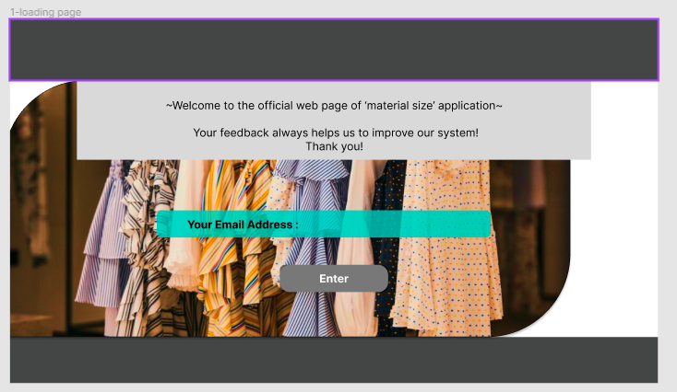

Figure 35. UI of customer entering the email address page.

The customer can login to the system by entering the email address as shown in the figure 1. The email address is used to identify the user as it uploads to the database.

Figure 36. UI of customer entering the material and size of a past purchase page.

As in figure 2, From a previous purchase made through the brand, customer has to enter its material and the size of that purchased product, which would use as feedback and also helps to collect the data to train the model.

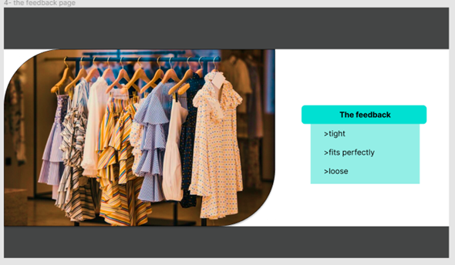

Figure 37. UI of customer feedback page

As the final page of the web application’s interface, customer can send the feedback for their previous purchased item as ‘tight or fits perfectly or loose’, using the given options, as shown in the figure 3.

### Database and Integration

The web application is connected is first connected to the MongoDB atlas database with ASP.NET Core. Then the data would be retried from the database for to send it to the mobile application using java.

### High level architecture

Figure 38. high-level architecture

# Chapter 06

## **Initial Project Plan**

Table 1. Gantt Chart for the proposed system.

As it shown in the table 1, according to the Gantt chart of this proposed system, the background research, data collection and analysis, as well as creating the user interfaces for both web and mobile applications are done and completed. Starting from the 3rd week of December the frontend development stage would begin.

# Chapter 07

## **Risk Analysis**

### Technical risks

* Security risks about user authentication and code securing.
* Sending the mobile application and web application data to the database.
* Can occur errors such as database authentication errors.
* Displaying the availability of the stocks correctly.
* When a user or customer buy a product, the related code set should be able to update the stock accurately.
* Navigating to the respective pages of the applications.
* The scalability of the system.

### Operational risks

* Data backups
* Uses a cloud-based version control tool such as git and GitHub to make a backup of the system.

Business risks

* Accuracy of the size recommendations.
* This decides whether the user would stay and interacts with the system in future as well, while gaining the customer loyalty.
* Customer feedback.
* Feedback about the entire system as well as the user experience.

# Chapter 08

## **Mobile Application User Interfaces.**

The mobile application UIs are designed as this for now.

Figure 39. UIs of user login page and the entering user chest size page.

As in figure 5, these user interfaces of the mobile application are for the user to first login to the system, and then can enter the user’s chest size body. So, the chest size would be compared with the clothing brand’s size chart.

Figure 40. UIs of clothing item list page, selecting the material page, clothing items according to the preferred material attributes page, respectively.

According to figure 6, user can either select a clothing item of any material, or else can directly go to the next option of user selecting a clothing material first and then select the clothing item according to the selected material using the navigation bar’s ‘Material’ button.

Figure 41. UIs of size recommendations and availability page and payment page.

As in the figure 7, after selecting the preferred clothing item, user would direct to the interface of recommending the best fitting size. Also, below that, displays the available sizes of that clothing. Then after, user can make the payment for the selected item using PayPal method.

# **References**

Administration, I. T., 2021. *eCommerce Sales & Size Forecast.* [Online]   
Available at: https://www.trade.gov/ecommerce-sales-size-forecast  
[Accessed 10 November 2023].

Coresight & Zheng, S., 2023. *The True Cost of Apparel Returns: Alarming Return Rates Require Loss-Minimization Solutions.* [Online]   
Available at: https://coresight.com/research/the-true-cost-of-apparel-returns-alarming-return-rates-require-loss-minimization-solutions/  
[Accessed 13 November 2023].

Yin, W. & Xu, B., 2021. *Effect of online shopping experience on customer loyalty in apparel business-to-consumer ecommerce,* s.l.: Sage Journals.

Dopson, E., 2023. *Ecommerce Returns: Expert Guide to Best Practices (2024).* [Online]   
Available at: https://www.shopify.com/enterprise/ecommerce-returns  
[Accessed 12 November 2023].

Al-dweeri, R. M. et al., 2017. *The Impact of E-Service Quality and E-Loyalty on Online Shopping: Moderating Effect of E-Satisfaction and E-Trust,* s.l.: ResearchGate.

Kumar, D. V. & Singh, R., 2014. *Women Online Shopping: A Critical Review of Literature,* s.l.: SSRN.

Hashmi, M. F. et al., 2020. *FashionFit: Analysis of Mapping 3D Pose and Neural Body Fit for Custom Virtual Try-On,* s.l.: IEEE.

Abdulla, G. M., Singh, S. & Borar, S., 2019. *Shop your Right Size: A System for Recommending Sizes for Fashion products,* s.l.: ACM Digital Library.

Polke, N. & Kumari, S., 2018. *Avatar Manager System for Online Fashion Clothing APP,* India: IEEE.

Yuan, Y., Park, M.-J. & Huh, J.-H., 2021. *A Proposal for Clothing Size Recommendation System Using Chinese Online Shopping Malls: The New Era of Data,* s.l.: MDPI.

Romain Guigourès, Y. K. H. K.-S. S. B. S., 2018. *A hierarchical bayesian model for size recommendation in fashion.* s.l., ResearchGate.

**STAGE PLANS**

Figure 42: Gantt Chart

# **INTERIM REPORT**

**Interim Report**

Table of Contents

Chapter 01 Introduction 74

**1.1** **Introduction** 74

**1.2** **Problem Definition** 76

**1.3** **Project Objectives** 77

Chapter 02 System Analysis 79

**2.1 Facts Gathering Techniques** 79

**2.2 Existing System** 84

**2.3 Use case diagram** 85

**2.4 Drawbacks of the existing system** 86

Chapter 03 Requirements Specification 87

**3.1 Functional Requirements** 25

**3.2 Non-Functional Requirements** 26

**3.3 Hardware / Software Requirements** 27

**3.4 Networking Requirements (Optional)** 88

Chapter 04 Feasibility Study 89

**4.1 Operational Feasibility** 89

**4.2 Technical Feasibility** 89

**4.3 Outline Budget** 89

Chapter 05 System Architecture 90

**5.1 Class Diagram of Proposed System** 90

**5.2 ER Diagram** 23

**5.3 High-level Architectural Diagram** 92

Chapter 06 Development Tools and Technologies 93

**6.1 Development Methodology** 93

**6.2 Programming Languages and Tools** 93

**6.3 Third Party Components and Libraries** 96

**6.4 Algorithms** 97

Chapter 07 Discussion 99

**Overview** 99

**Summary** 99

**Challenges Faced** 99

**Upcoming Work** 100

**Appendix** 101

**References** 105

**Table of Figures**

Figure 1: Pie chart showing the importance of clothing materials 7

Figure 2: Bar chart of online sales in 2019 (Administration, 2021) 76

Figure 3: The Questionnaire about the best fitting size recommendation system 79

Figure 4: Pie chart showing respondents’ gender 80

Figure 5: Pie chart showing respondents’ Age 80

Figure 6: Pie chart showing the importance of materials 81

Figure 7: Pie chart showing respondents’ confidence about getting correct size 81

Figure 8: Pie chart showing respondents’ experience with the online size recommendation systems 82

Figure 9: Pie chart showing respondents’ preference about a size recommending application 82

Figure 10: Questionnaire about asking correct UK sizes for the specific materials 83

Figure 11: Use Case diagram 21

Figure 12: Code set of user authentication 26

Figure 13: Class Diagram 22

Figure 14: ER Diagram 23

Figure 15: High-level Diagram 24

Figure 16: Gantt Chart 93

Figure 17: Postman API request body showing the test HTTP requests 94

Figure 18: MySQL database table of showing how the test post requests are being updated 17

Figure 19: Postman API’s response to the testing request. 95

Figure 20: Frontend UI of the user feedback page 97

# Chapter 01 Introduction

## **Introduction**

According to a survey conducted by Coresight Research, within US apparel brands and retailers, discovered that the average return rate of the online apparel sales in US is about 24.4% (Coresight & Zheng, 2023). The reasons for high return rates in online clothing are people having different body shapes and compared to the user body measurements the clothing brand’s size chart measurements with clothing item specifications being different. Materials can be stretchable or non-stretchable and should be highly considered when buying the product.

According to the questionnaire survey that conducted for this project, 62.5% of respondents stated that the material is important when purchasing a clothing item or an apparel as shown in figure 1 below. Thus, 31.3% of respondents stated that it is very important. None of the respondents say that the material consideration is not important.



Figure 43: Pie chart showing the importance of clothing materials

Cotton, Polyester, Linen, etc., materials can be considered as non-stretchable and usually require a bigger size of the product. While stretchable materials like Spandex blend fabrics such as Polyester/ Spandex blend or elastane need a smaller size in comparison to non-stretchable fabrics.

In a study that collected data from the in-person interviews were asked about online apparel shopping and its feedback. Both ‘product quality’ and ‘return and exchanges’ topics were mentioned 18 times each. Which mentioned more often than the other topics (Yin & Xu, 2021).

Since the quality of the product matters, the developing system provides the user with a feature to select the preferred materials of the clothing according to their likings. Which gives a certainty about the product quality. It can be fully 100% cotton/ polyester/ linen or else it can be a spandex blend material.

According to Statista, comparing to other retail product categories such as shoes, bags and accessories, the highest returned rate which is 26% is for the clothing items among all the categories (Dopson, 2023). Since not all the customers are happy with the online clothing purchasing, developing a system that can recommend the best fitting size before buying the actual product would be a better solution.

The developing system is called ‘Material-related size recommendations’, can recommend the perfectly fitting size for the user by getting one user specific body measurement such as user’s chest size. Then that measurement would be compared with the specific clothing brand’s size chart, while considering the material aspects of that clothing item as well. In addition to that, the material-wise size recommendation data would be gathered from previous customer purchases made from a specific brand. (In here it only focuses about a specific brand and can use this exact solution to expand this system while collaborating with several other brands.)

This system collects the data about customer’s order history through a page where user can enter their chest width, material of the clothing they bought, and the fitted size when do both physical and online shopping. Using all these data, system can give the user a material-related size recommendation.

Data from several surveys found that men have more trust in online shopping (purchases) than women who reported have lesser trust (Kumar & Singh, 2014). Therefore, the developing system would be mainly focused on women and the age range of 20-54. Since women found difficulties with the materials related sizes mostly.

The developing system uses a mobile application which provides user-friendly user interfaces (UIs) for the user to get the recommended fitting size of the clothing item. In addition to that some more features are available in this application such as user feedback which could improve the reliability of the system.

Through the react native mobile application, the user can enter the user-specific body measurement which is the chest size, and that data would be sent to the related databases to give the best fitting size. And technologies as react native for the mobile application frontend, MySQL database with java spring boot for the backend would be use as a full- stack.

## **Problem Definition**

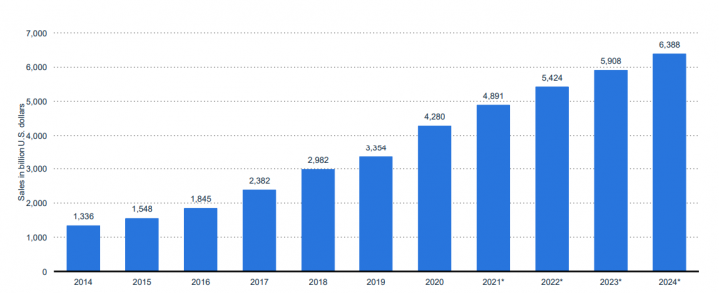

Figure 44: Bar chart of online sales in 2019 (Administration, 2021)

After the covid19 pandemic in 2019, the worldwide online shopping sales has rapidly increased as shown in the above figure 2. Furthermore, 8 percent of increment in online shopping sales can be seen within the next couple of years in comparison to past few years, for all sectors including fashion clothing (Administration, 2021).

According to a study, it reported that according to Bloomberg, even after the COVID 19 ended 41% of American people claimed to like online shopping (apparel and other items) more than visiting the shop and purchase items physically. Furthermore, it stated in a survey that conducted in 2022, online sales are booming in the China as ¾ of are related to clothing and fashion categories (Vaghasiya & Sitapara, 2023). These reported data display how much online shopping in apparel or clothing sectors has boosted up.

Although apparel and clothing sales has shown a major growth in the online shopping, the return rates of those sectors also have been highly increased as stating 40% to 50% (Cullinane, et al., 2017). As the following research paper and other data shows, the high return rates globally have become a big issue in online appeal shopping. To overcome this problem, creating a system that recommends a best fitting clothing size for the customers would be great. Thus, creating a mobile application where user enters his/her chest size and gather the user feedback of past purchases made from that specific brand and feed to the model to give excellent size recommendations would be the best solution.

## **Project Objectives**

Main objectives

1. Recommend the best fitting clothing size for the user according to the body measurement, and the material attributes with compared to the brand size chart measurements.
2. Target users are women who’s in between age rage of 20-54 for this system.
3. Ability to select a clothing item according to the preferred clothing material.
4. Displays the current stock availability of an item.
5. Able to purchase and make the payment through PayPal sandbox.
6. Provides a user feedback system that can improve the model.
7. Improves online shopping experience.

Specific objectives

1. A mathematical model would compare both the user-specific body measurement (chest size) and the clothing material with the clothing brand’s size chart, then find the best fitting clothing size such as UK size 8/ 10/ 12/ 14/ 16 for the user.
2. Analyzing using only one body measurement which is the user chest size (width), because it is convenient for the users to measure and put only one body measurement rather than taking a lot of time to give all other his/ her body measurements.
3. A feature for the user to first select a material such as cotton, linen, polyester, or spandex blend fabrics such as polyester, elastane. After selecting the preferred material could select a clothing item from the list of cloths according to the user-selected material.

This value-added feature benefits the users to find the exact same material that searching for. When the selected clothing item is delivered, can find whether it has the exact same material attributes. This minimizes low quality and wrong order delivery. Thus, increases brand loyalty.

1. Payment using PayPal sandbox feature, the user can make the payment after getting the size recommendation and the availability of that selected product.
2. Users can leave feedback about their previous purchases, so that it would improve the reliability of system, can keep make much better recommendations with time goes on.
3. As for high return rates in apparel such as for blouses and tops, the developing system could assist the user to find the best fitting clothing item while reducing the return rates.

# Chapter 02 System Analysis

## **2.1 Facts Gathering Techniques**

Facts gathering techniques can be listed in 2 parts, such a primary and secondary data gathering techniques. As for the primary data gathering, have conducted a survey questionnaire to gather data about different perfectives for the developing system.

Figure 45: The Questionnaire about the best fitting size recommendation system

In the figure 3 shows, the questionnaire which is about asking the participants to enter their gender, age, and how important the material is when buying an clothing item, the confidence about getting the expected matching size when buying the item online, and if the participants has ever used/experienced an online size recommendation system or an app, moreover, if the participants like to have/ use an online size recommending system application in their day to day life. Thus, the full questionnaire can be viewed under the appendix section.

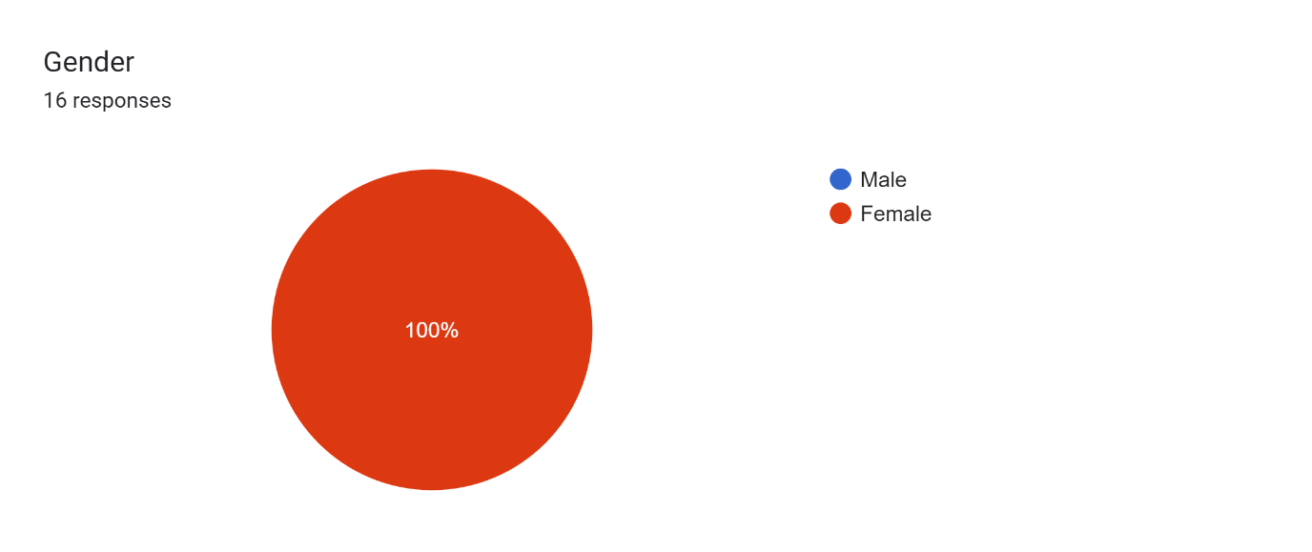

Figure 46: Pie chart showing respondents’ gender

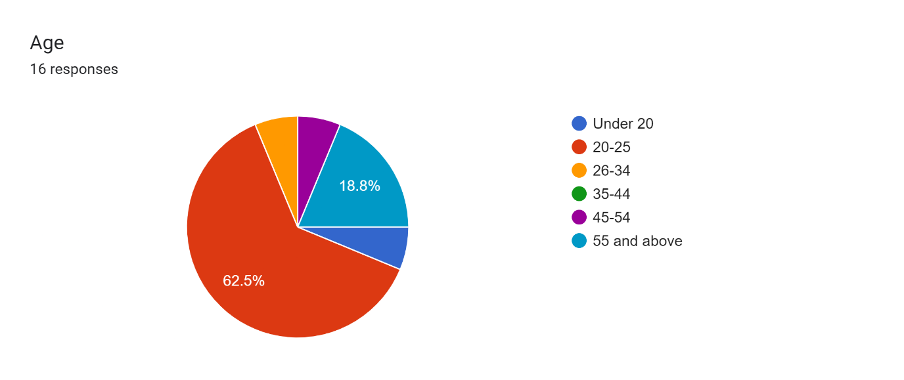

Figure 47: Pie chart showing respondents’ Age

Since the developing application’s target audience is females between 20 to around 54 aged people, from that criterion the data would be collected. As in the figure 4, and 5 above, it shows the responses or the results of this questionnaire. While all the respondents are female and with all combined 93.9% of respondents are in between the age of 20-54. (Considering that under 20 aged females would not be used for collecting the data since the developing application mainly targets ages between 20-54 women.



Figure 48: Pie chart showing the importance of materials

Forms response chart. Question title: How confident are you in choosing the correct size when do online shopping?
. Number of responses: 16 responses.

Figure 49: Pie chart showing respondents’ confidence about getting correct size

Figure 6 and 7 describes about the importance of the material and how accurate the sizes are when buying the product online. While in figure 8 and 9 below describes, whether if the user has already experienced online size recommendation systems and if she/he would like to experience such an application.

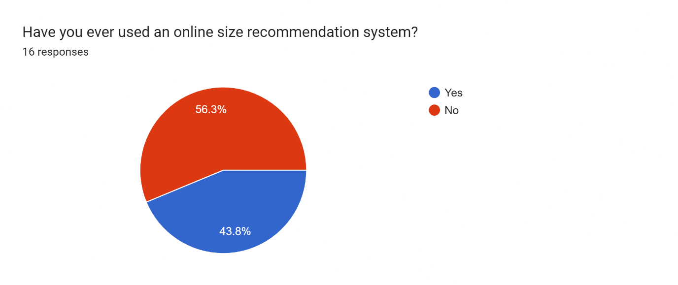

Figure 50: Pie chart showing respondents’ experience with the online size recommendation systems

Forms response chart. Question title: Would you like an app that provides size recommendations for you based on your body measurement relates to clothing item&apos;s material ?
. Number of responses: 16 responses.

Figure 51: Pie chart showing respondents’ preference about a size recommending application

As the mathematical model’s training dataset expected to use the survey data which includes questions such as the preferred UK size for different materials such as cotton, polyester, linen and spandex-blend fabrics or materials as it shows in the figure 10 below for the cotton material. However, this technique of using the survey data did not succeed because having low number of responses. If were to use this method, must have at least 200 responses.

Figure 52: Questionnaire about asking correct UK sizes for the specific materials

As for the secondary data gathering, have gathered data from existing systems which would be described in the following topic about 2.2 Existing System.

## **2.2 Existing System**

Using ‘FashionFit’ system, user can virtually try on any unbranded clothing item from any retailers using AI. The 3D pose maps the user’s body and Neural body fit model creates 3D models of the body according to the body shapes. Then able to virtually try on the clothing using GANs framework in machine learning (Hashmi, et al., 2020). In that system it uses 3D body pose to map the user’s body based on an image.

A system where gathers the data about user’s previous purchases, and with the specific clothing item’s details, predicts the suitable size of for user using the GBM classifier as reduces the return rates (Abdulla, et al., 2019). By analyzing a collection of data, system would be able to tell the size of clothing that is recommended for the user and without fully need of the visualization.

Research about ‘Avatar manager system’, developed a system where the user can try on the clothing item, he/she likes on an avatar when do online shopping. Men and women can select a suitable body type which matched for each user from the given options. Then after should select the preferred body size such as small or large or extra-large, etc. In the end of this process user can adjust the avatar’s body measurements compared to the user’s body measurements. Then it would display how the selected clothing item would fit on according to the user’s body measurements (Polke & Kumari, 2018).

THE FIT (Korea) implemented an AI-based system in online shopping malls, that recommends the suitable shoe size for the customer. This application collects the data about customer’s order history and compares that data with the customer’s actual foot size and recommends a shoe size from currently available shoe products (Yuan, et al., 2021).

According to a system that implemented using a Hierarchical Bayesian model. It can recommend a size for the product by checking the highest probability about customer keeping the product without returning it and according to their preference through using a survey conducted about millions of purchase data (Romain Guigourès, 2018).

## **2.3 Use case diagram**

Figure 53: Use Case diagram

The system name is ‘Size Recommendation system’ and actors are external objects that can be listed as primary actors, secondary actors. The primary actor in the developing system is the user/ customer which displays on the left side of the container/ system in the figure 11 shows above. These people can use the system to get the size recommendations.

In the other hand the secondary actor in here is the clothing brand shown in the right side of the figure 9. It reacts when the user/ customer selects an item and checks the stock availability and also when making the payment.

As for the use cases it has base and included use case. As an example, the login ‘base use case’ needs ‘included use case’ to verify and authenticate the user. Furthermore, this system has ‘extended use case’ which the relationship with the ‘base use case’ does not happen every time, such as when login to the system the login error message would not occur every time.

## **2.4 Drawbacks of the existing system**

According to the Fashion fit system (Hashmi, et al., 2020) mentioned above, this existing system uses augmented reality where the customer can virtually try on clothing items. Although it gives the user a better virtual experience, the accuracy of mapping the body coordinates could be rather low. However, the developing system is more relied on the data of buying history of each user and would train a model to provide accurate size recommendations.

Also, in Avatar manager system (Polke & Kumari, 2018) it creates an avatar to check whether the clothing item fits, where the user must select their body shape such as small/ large or extra-larger first. This could be a better easy approach for the user in terms of not needing to physically try on the product. But since it is asking the user to select the shape of his/her body shape, the accuracy of choose the correct size of the avatar and adjusting user body measurements to it could be somewhat would not give accurate results.

# Chapter 03 Requirements Specification

## **3.1 Functional Requirements**

* Displaying the best fitting UK size for the user selected clothing item.
* Could select the clothing item according to the preferred material.
* Ability to give user feedback about previous purchases made.
* Feature to see the stock availability.
* Able to make payments using PayPal.
* Able to login to the system once a user has registered.

## **3.2 Non-Functional Requirements**

* Security:

According to the figure 12 below, only if the user exists in the system the user can login. In a register table users can register so the new record with the user details would be added. Then after when the user logs in, data would be retrieved and would be checked.

Figure 54: Code set of user authentication

* Accessibility

The application can run on both iOS and Android improving the accessibility of the system to the user being a cross-platform application.

* Maintainability

And have also used getters and setters in java encapsulation as a security measurement. Which helps to improve maintainability of the code structure and the security.

* UI and UX

Provides better user experience and user-friendly UI while securing the data.

## **3.3 Hardware / Software Requirements**

Hardware

A Mobile phone (Android/ iOS) and a computer that has accessed to Wi-Fi and has enough RAM (ex: 8GB and 8GB< would be preferred) and CPU.

Software

Node js should be installed prior to installing this application. Thus, Visual studio code IDE is used to run the react-native application. And IntelliJ IDEA is used for the java spring boot backend with MySQL workbench application to run the database.

## **3.4 Networking Requirements (Optional)**

To run this application the development machine and the user’s mobile phone needs to be in the same (Wi-Fi) network, so the development machine’s IP address can be accessed by the mobile phone. Since the development machine would be the remote server and have to use its IPv4 address in the react-native’s frontend for axios request URL, to interact with the java spring boot with MySQL backend.

# Chapter 04 Feasibility Study

## **4.1 Operational Feasibility**

When first starting this application, it needs to run the ‘npx react-native run-android’ command on the terminal or command prompt inside the folder where the project is located. Furthermore, needs to be in the same Wi-Fi network connection while running both the java spring backend and the react native metro builder. Thus, needs to put the related IPv4 inside the axios request URL.

## **4.2 Technical Feasibility**

The developing application is running on react-native. And react-native is a cross-platform. By running ‘npm start’ on the command prompt or the terminal, can select the platform that should be running this application. Can run this system on Android, IOS or Web (reactnative.dev, n.d.).

When it comes to running and connecting to the server, cannot use localhost to make requests to the server through development machine, since it is using a remote server. Only using the development machine’s local IP address (ex: IPv4 - Internet Protocol version 4) we can access this server. Mobile application can also access this IP address since it is also connected to the same network as the development machine.

## **4.3 Outline Budget**

For this developing system have not used any additional paid software licenses or libraries. Thus, this system’s outline budget would be none, since as for MySQL database is also not hosted on a cloud service in this project.

# Chapter 05 System Architecture

## **5.1 Class Diagram of Proposed System**

The visibility of the methods and attributes are shown using the + or – symbol public and private access specifiers accordingly as shown in the figure 13 below. User can give feedback as well as can enter his/her chest size. After entering the user size, user could select a clothing item from the list, then from that would give user the best fitting size recommendation and the stock availability.

Figure 55: Class Diagram

## **5.2 ER Diagram**

Figure 56: ER Diagram

The entities of this system are user, feedback, and clothing items. As shown in the figure 14, user can send feedback, also assume that one user sends only one feedback while feedback is sent by a user. Furthermore, while clothing items has user feedback, the user can also buy the selected clothing item.

## **5.3 High-level Architectural Diagram**

As for the high-level diagram such changes were developed when compared to the previous high-level diagram. As according to the new high-level diagram in the figure 15 below, from react-native application (frontend), would send the http request to the java spring server. Then after processing the requests and it performs the specific tasks while connecting and interacting with MySQL database as necessary.

Figure 57: High-level Diagram

# Chapter 06 Development Tools and Technologies

## **6.1 Development Methodology**

Figure 58: Gantt Chart

This developing system can be considered as using a hybrid approach methodology, where it is a combination of waterfall and agile methodologies. As the Gantt chart shows above in the figure 16, first created few user interfaces as login, register, and enter size pages from week 10 to 13. Which can be considered as waterfall methodology to work on a one task before going to the backend development. Then after the entire project has done using agile methodology.

After the week 13 have continuously developed both frontend and the backend together to develop and deliver a working product such as an entire feature. For that used an iterative approach which includes sprints. The testing has also started while doing the backend development to overcome big issues that can occur later, and this can be considered as characteristics of the agile methodology as do testing throughout the development process.

## **6.2 Programming Languages and Tools**

Programming Languages

React-native framework is used to develop the frontend of this mobile application, while for the backend it uses Java Spring Boot framework with MySQL database. This can be considered as a great stack for developing a mobile app. MySQL is hosted on a remote server using port 3306 which use to communicate to a network, while for java spring boot it is using the tomcat server with port 8080 to run that its server and the React’s metro is running on the port 8081.

Tools

* Testing

Uses postman as a tool, to test the HTTP requests and its responds. Under collections have created a new collection called ‘Sizerecom’. There a new POST request is send to the ‘http:// 192.168.186.125:8080/user’ endpoint (IPv4 address) and that request would be sent in a JSON format as shows in the figure 17 below,

Figure 59: Postman API request body showing the test HTTP requests

When the request is sent, it would update the MySQL database tables as in the figure 18 below. So, then it could test the APIs in this application as it uses ‘PostMapping’ annotation in java spring boot to handle and send the POST requests.

Figure 60: MySQL database table of showing how the test post requests are being updated

A new GET request is made to get (retrieve) the data and view all users in endpoint of ‘/allusers’. As can see in the figure 19, the ID is auto incrementing by one using the ‘@GeneratedValue’ annotation with ‘@Id’ annotation. The Id then used as the primary key.

Figure 61: Postman API’s response to the testing request.

* Version Control

For every project it is important to use good amount of version control, to keep backups and for code maintainability. As for this developing application, the data is committed/ saved on two different branches as ‘testdev’ and main. First each feature’s backend part and frontend part would be committed to the testdev subbranch, then after if both frontend and backend of that feature is working fine, it would be committed to the main branch from the ‘testdev’ branch.

## **6.3 Third Party Components and Libraries**

For the mobile application have used third party components and libraries to add more additional functionalities to the system while creating the application well organized by enhancing the user experience also.

1. @react-navigation/native

* This can navigate the user from one screen to another screen using the navigate (‘’) method.

1. @react-navigation/stack

* This creates a stack, so if put ‘A’ screen on top and ‘B’ screen under that, this library can stack them and would go to the screen ‘A’ first the navigates to the screen ‘B’.

1. npx react-native link react-native-gesture-handler react-native-screens react-native-svg

* Since the ‘Button’ component in react-native does not include many options when it comes to editing or styling the component, in here it uses a component called ‘TouchableOpacity’ which can easily be styled and act as a button.

1. react-native-screens library

* uses to create a stack where navigate between the screens.

1. @react-navigation/native @react-navigation/bottom-tabs

* to create the bottom navigation bar in most of the pages

1. @react-native-picker/picker

* To create the dropdown list in the ‘Material.jsx’ page

1. Axios library

* uses this library to make http requests from the react-native app to the server.

## **6.4 Algorithms**

This project uses a mathematical model to give size recommendations to the users and focuses on a one specific brand. This application provides the user a user feedback page. Since each brand has their own size charts with its measurements, this system asks the user to select his/her chest size from various size ranges as shown in the figure 20 below. And behind every chest size selection label it has the brand’s UK size for that specific size range (for the developer purposes). This code structure is planning to be used in the mathematical model.

Figure 62: Frontend UI of the user feedback page

Furthermore, for this mathematical model user must enter the material of the clothing he/she bought, together with the chest size, because in here are analyzing how the sizes are being vary with the material of the clothing. And though it is not developing in this system, as a future development can also use the same technics for the clothing item designs also, as how the sizes are varying with the design of the clothing (Cami Tops, Cross-Over Tops, Kaftan Tops, Flared Tops). Thus, this can be considered as an additional future development, and would not be developed in the current application.

# Chapter 07 Discussion

## **Overview**

As an overview of this report, the introduction is where the problem definition and the project objectives are also included. Furthermore, the project objectives can be divided into main and specific objectives. Fact gathering technics like questionnaires and data about existing systems with its drawbacks are included in the system analysis section of the project.

In the requirement specifications section, functional, non-functional with hardware/software and network requirements are included. Operational and technical feasibility were discussed and for system architecture different diagrams that are required were mentioned. A hybrid method of approach was used for the methodology. Thus, third-party libraries were installed, to have different functionalities to the system.

## **Summary**

When a person does online shopping, finding the best fitting correct size for she/he is somewhat difficult. Furthermore, for online shopping women have low trust in buying the apparel (Kumar & Singh, 2014). So, developing a system that only focuses on women, providing online size recommendations would be the best. This developing system would give the size recommendations based on the material attributes, since the size can be varied with the clothing item’s material. More ever, this system would use the brand’s size chart with its measurements to give the best recommendations.

## **Challenges Faced**

For this system, to develop the mathematical model it was planned to use the questionnaire result data. However, since the responses from the questionnaire was not enough, the accuracy of training the model using those data would not be reliable. So currently it is planned to use dummy data for the user feedback page as entering the data about user’s previous purchases (fitted size and material details). Using the dummy data would not be an issue since in the real-life application, the same method could be used to train the model using real users. In addition, with the time being the reliability of this system would be increased.

## **Upcoming Work**

It is not clearly decided what/ how the mathematical model would be created. But it has yet to be created and designed taking the user feedback and gathering data. This application uses dummy data as user feedback. And from that data could create the model after analyzing the data. After this step is done, needs to display the recommended size for each user from the selected product or clothing item with the stock availability.

# **Appendix**

The questionnaire about the developing/ proposed system can be seen below respectively.

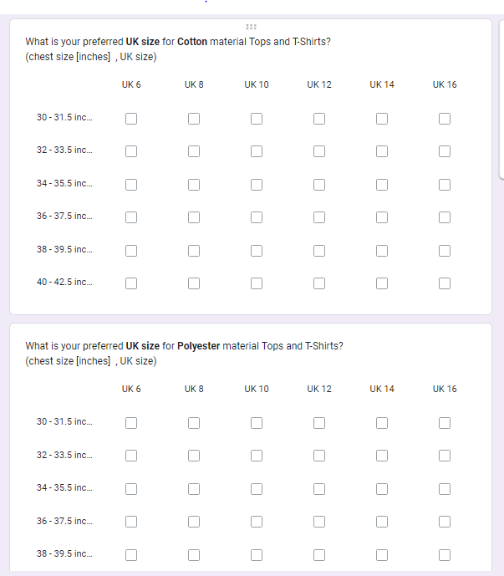

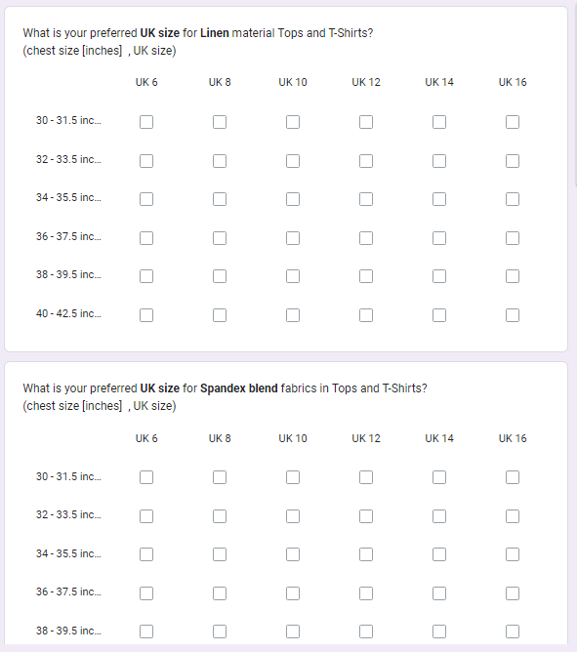



# **References**

1. Coresight & Zheng, S., 2023. The True Cost of Apparel Returns: Alarming Return Rates Require Loss-Minimization Solutions. [Online]   
   Available at: https://coresight.com/research/the-true-cost-of-apparel-returns-alarming-return-rates-require-loss-minimization-solutions/  
   [Accessed 13 November 2023].
2. Yin, W. & Xu, B., 2021. Effect of online shopping experience on customer loyalty in apparel business-to-consumer ecommerce, s.l.: Sage Journals.
3. Dopson, E., 2023. Ecommerce Returns: Expert Guide to Best Practices (2024). [Online]   
   Available at: https://www.shopify.com/enterprise/ecommerce-returns  
   [Accessed 12 November 2023].
4. Kumar, D. V. & Singh, R., 2014. Women Online Shopping: A Critical Review of Literature, s.l.: SSRN.
5. Administration, I. T., 2021. eCommerce Sales & Size Forecast. [Online]   
   Available at: https://www.trade.gov/ecommerce-sales-size-forecast  
   [Accessed 10 November 2023].
6. Vaghasiya, C. & Sitapara, J., 2023. A STUDY ON RETURNS RATES IN THE FASHION INDUSTRY WITH REFERENCE TO AN E-COMMERCE BUSINESS, s.l.: JETIR.
7. Cullinane, S., Karlsson, E., browne, m. & Wang, Y., 2017. Retail clothing returns: A review of key issues, s.l.: ResearchGate.
8. ReactNative, n.d. Introduction. [Online]   
   Available at: https://reactnative.dev/docs/getting-started  
   [Accessed 28 February 2023].
9. Hashmi, M. F. et al., 2020. FashionFit: Analysis of Mapping 3D Pose and Neural Body Fit for Custom Virtual Try-On, s.l.: IEEE.
10. Abdulla, G. M., Singh, S. & Borar, S., 2019. Shop your Right Size: A System for Recommending Sizes for Fashion products, s.l.: ACM Digital Library.
11. Polke, N. & Kumari, S., 2018. Avatar Manager System for Online Fashion Clothing APP, India: IEEE.
12. Yuan, Y., Park, M.-J. & Huh, J.-H., 2021. A Proposal for Clothing Size Recommendation System Using Chinese Online Shopping Malls: The New Era of Data, s.l.: MDPI.
13. Romain Guigourès, Y. K. H. K.-S. S. B. S., 2018. A hierarchical bayesian model for size recommendation in fashion. s.l., ResearchGate.

# **Records of supervisory meetings**

